**MMSU VR CHRONICLES: A VIRTUAL REALITY GAME TIME CAPSULE OF THE HISTORY OF MARIANO MARCOS STATE UNIVERSITY**

**CAPSTONE PROJECT**

**JHON CHRISTIAN G. AGTINA**

**AEDRIELLE N. ASCAÑO**

**JAYTHER JANN F. BUA-AY**

**ALVEE JAY V. ESTAVILLO**

**Bachelor of Science in Information Technology**



**Department of Information Technology**

**COLLEGE OF COMPUTING AND INFORMATION SCIENCES**

**Mariano Marcos State University**

**City of Batac 2906 Ilocos Norte**

**May 2024**

**MMSU VR CHRONICLES: A VIRTUAL REALITY GAME TIME CAPSULE OF THE HISTORY OF MARIANO MARCOS STATE UNIVERSITY**

**JHON CHRISTIAN G. AGTINA**

**AEDRIELLE N. ASCAÑO**

**JAYTHER JANN F. BUA-AY**

**ALVEE JAY V. ESTAVILLO**

**A Capstone Project Presented to the Faculty of the**

**Department of Information Technology**

**In Partial Fulfillment of the Requirement of the Degree**

**Bachelor of Science in Information Sciences**

**May 2024**

**ACCEPTANCE SHEET**

The thesis attached, entitled **“MMSU VR CHRONICLES: A VIRTUAL REALITY GAME TIME CAPSULE OF THE HISTORY OF MARIANO MARCOS STATE UNIVERSITY”,** prepared and submitted by **JHON CHRISTIAN G. AGTINA, AEDRIELLE N. ASCAÑO, JAYTHER JANN F. BUA-AY, ALVEE JAY V. ESTAVILLO** with Contribution Number **2024-04-0003** in partial fulfillment of the requirements for the degree **BACHELOR OF SCIENCE IN INFORMATION TECHNOLOGY** is endorsed:

**WILBEN CHRISTIE R. PAGTACONAN ______________**

Adviser Date Signed

**RALPH C. PERDIDO ______________**

Member, Advisory Committee Date Signed

**RENZIE A. AGUADA ______________**

Member, Advisory Committee Date Signed

**CHARLES CHILE G. ABLETES ______________**

Member, Advisory Committee Date Signed

Accepted in partial fulfillment of the requirements for the degree **BACHELOR OF SCIENCE IN INFORMATION TECHNOLOGY.**

**NAPOLEON M. CACANINDIN, DIT**

Chair, Department of Information Technology

Date Signed: ________________

**SATURNINA F. NISPEROS, PhD.**

Dean, College of Computing and Information Sciences

Date Signed: _________________

**ABSTRACT**

**AGTINA, JHON CHRISTIAN G., ASCAÑO, AEDRIELLE N., BUA-AY, JAYTHER JANN F., ESTAVILLO, ALVEE JAY V.** College of Computing and Information Sciences, May 2024. **“MMSU VR CHRONICLES: A VIRTUAL REALITY GAME TIME CAPSULE OF THE HISTORY OF MARIANO MARCOS STATE UNIVERSITY.”**

Contribution Number: 2024-04-0003

Adviser: **WILBEN CHRISTIE R. PAGTACONAN**

The MMSU VR Chronicles aimed to develop an immersive VR experience showcasing the history of Mariano Marcos State University (MMSU) through Virtual Reality (VR) to preserve the university’s history. Specifically, the project focused on collecting comprehensive historical data, developing an education VR app, and analyzing user acceptability of the VR application. This project aligns with the goals of utilizing VR’s immersive capabilities to present the history of MMSU and aims to create an engaging, gamified learning environment.

The project used the descriptive research method through museum in-charge interviews and user acceptability tests (UAT) based on ISO 25010 standards was conducted with purposive sampling, while Scrum was used as the software development methodology. Blender and Unreal Engine 5 were the main tools in developing the project. Results from the UAT showed an overall mean score of 4.55 among the student respondents, indicating strong agreement on the application’s functional sustainability, usability, efficiency, reliability, and compatibility. Museum personnel gave a slightly lower mean score of 4.01.

The project’s significance lies in its ability to integrate VR technology in history education, specifically regarding the foundation of Mariano Marcos State University, and introduce a new approach to immersive learning. This project also addresses traditional teaching challenges, improving engagement and information retention through active exploration and gamification.

Future researchers are suggested to further optimize VR applications especially when using assets such as the MetaHuman Plugins and materials to minimize system requirements in post-deployment. Additionally, it is advised to invest in high-performance computers during the development phase.

**ACKNOWLEDGMENT**

We would like to express our heartfelt gratitude to everyone who supported us throughout the completion of this capstone project.

To our capstone project adviser, **Prof. Wilben Christie R. Pagtaconan**, for guiding us throughout this project. Your insightful feedback, encouragement, and constant support have helped us mold and materialize this project to life.

To our panel members, **Mr. Ralph C. Perdido**, **Mr. Renzie A. Aguada**, and **Mr. Charles Chile G. Abletes**, for their professional advice and comments towards the development of this project.

To the director of the University library, **Mrs. Eliza G. Villarin**, and also to the personnel in-charge of the MMSU Museo, **Ms. Delna Liwaden** and **Ms. Charie Kaye F. Colar**, for accommodating us and participating with us for the success of the project.

To our **professors** and **faculty members** at **College of Computing and Information Sciences** for providing a solid foundation of knowledge and environment for learning.

To the **respondents**, who gave their time and effort in evaluating our capstone project.

To our **parents**, for the financial and moral support they have given us. Their belief in us motivated and focused.

To our **friends** and classmates who extended their hand to help and support us in creating the project.

Most of all, we are all greatly grateful to our **Almighty Creator**, for providing us knowledge, wisdom, and strength. We thank you all for your invaluable contributions.

**J.C.G.A**

**A.N.A**

**J.J.F.B**

**A.J.V.E**

**TABLE OF CONTENTS**

| **TITLE** | **PAGE** |
| --- | --- |
| **TITLE PAGE** | i |
| **PRESENTATION PAGE** | ii |
| **ACCEPTANCE SHEET** | iii |
| **ABSTRACT** | iv |
| **ACKNOWLEDGEMENTS** | v |
| **TABLE OF CONTENTS** | vi |
| **LIST OF FIGURES** | vii |
| **LIST OF APPENDICES** | viii |
| **INTRODUCTION** | 1 |
| Project Context | 1 |
| Objectives of the Study | 3 |
| Scope and Limitations | 4 |
| Significance of the Study | 5 |
| **REVIEW OF RELATED LITERATURE** | 6 |
| Review of Related Systems | 20 |
| Review of Related System Matrix | 25 |
| Conceptual Framework | 26 |
| **METHODOLOGY** | 27 |
| Research Design | 27 |
| Data Gathering Tool | 27 |
| Data Gathering Procedure | 28 |
| 3D Modeling Procedures | 29 |
| Population and Sampling | 31 |
| Software Development Methodology | 31 |
| **RESULTS AND DISCUSSIONS** | 33 |
| Initial Survey for Sampling | 33 |
| Requirements Documentation | 36 |
| Application Interface | 39 |
| User Acceptance Test | 47 |
| **CONCLUSION AND RECOMMENDATIONS** | 49 |
| **REFERENCES** | 51 |
| **APPENDICES** | 55 |

**LIST OF FIGURES**

| **FIGURE** |  | **PAGE** |
| --- | --- | --- |
| 1 | Screenshots of Arnswalde VR | 20 |
| 2 | Screenshots of Wanderer | 21 |
| 3 | Screenshots of Brink Traveler | 22 |
| 4 | Screenshots of Time Machine VR | 23 |
| 5 | Screenshot of National Geographic Explore VR | 24 |
| 6 | VR Related System Matrix | 25 |
| 7 | Conceptual Framework | 26 |
| 8 | Virtual Human Modeling Process | 29 |
| 9 | Virtual Environment Modeling Procedure | 30 |
| 10 | Scrum Development Methodology | 32 |
| 11 | Percentage of Individuals Interest in Learning MMSU’s History | 33 |
| 12 | Percentage of Who Visited the Dioramas at MMSU Museo | 34 |
| 13 | Percentage of Individuals with Experience in Virtual Reality | 35 |
| 14 | Percentage of Individuals Interested in VR and MMSU History in VR | 36 |
| 15 | Use Case Diagram of the VR Application | 37 |
| 16 | Deployment Architecture | 38 |
| 17 | Development Architecture | 39 |
| 18 | Lobby | 40 |
| 19 | Control Instruction Widget | 40 |
| 20 | Objectives Widget | 41 |
| 21 | Other Controls Widget | 41 |
| 22 | Options Widget | 42 |
| 23 | Stage Selection | 42 |
| 24 | Interactions Widget | 43 |
| 25 | Stage 1 Outside | 44 |
| 26 | Stage 1 Inside | 44 |
| 27 | Stage 2 | 45 |
| 28 | Stage 3 | 45 |
| 29 | Stage 4 | 46 |
| 30 | Stage 5 | 46 |

**LIST OF APPENDICES**

| **APPENDIX** |  | **PAGE** |
| --- | --- | --- |
| **A** | Interview Letter | 56 |
| **B** | University Research Ethics Review Board Clearance | 57 |
| **C** | Initial Survey Sample | 58 |
| **D** | User Acceptance Test Letter | 59 |
| **E** | User Acceptance Test Form | 60 |
| **F** | Diorama Stage and Presidents’ Information | 62 |

**INTRODUCTION**

**PROJECT CONTEXT**

Museums breathe life into our history and serve as gateways to our cultural heritage, fostering a profound connection between the past, present, and future. Among their many functions, one of them includes educating visitors. However, as considerable amounts of effort are needed in the process of learning, students often need motivation in completing complex tasks like reading textual information, where our brain processes symbols when reading from a printed document [1]. By implementing various approaches using technology, students are more likely to become interested in learning and be engaged with various topics.

An approach which was garnering attention at recent times was the use of virtual reality (VR) in learning. Through VR, users can experience things in an alternate created world, making a profound sense of immersion. Current technologies like Google Lens and Google Expeditions are accessible and easy to operate which enables instructors to make students experience virtual trips to museums and other places that seem out of reach [6]. Through the immersive capabilities of virtual reality (VR), it helps students be motivated, stimulate them in certain events and allows them to experience hands-on learning which, according to research, is proven to increase attention level twice and text results by 30% [1] [3]. This makes VR one of the technologies which support constructive learning, a way of learning that emphasizes the combination of senses, existing information, and new information in order for the learner to make new meanings and understandings [2]. Virtual reality has also been implemented in different domains such as engineering, science, health and general-purpose education as VR is observed to be more useful in these areas. It is used as training simulators to prepare students in the practical fields for real-world situations where concerns are minimized for teachers regarding cost, risk and time as it is often used in tandem with study materials [3].

In the context of history education, VR can provide an opportunity of learning the past as well as experiencing and internalizing it better than traditional teaching methods. Virtual reality environments in history courses are considered useful especially in highlighting important events (i.e. wars, negotiations, treaties, discussions etc.) as well as experiencing places that don’t exist anymore [3]. As these topics in history require content that must be communicated visually, by creating a VR condition, users can have a higher visual knowledge retention compared to AR conditions [4].

Moreover, museums also utilize technologies involving augmented (AR) and virtual realities in fulfilling their functions in educating visitors. In “reconstructing” experiences and artifacts, multimedia and the aforementioned technologies are one of the best in doing so as they help users’ imagination and interact with different scenarios [5].

In an interview with the University’s Library Director, it was stated that the MMSU museum had noticed a discernible drop in visitation, primarily attributed to the fact of the relocation of its artifacts and exhibits to a more confined space. Although there was still some residual interest, mostly from curious students, foot traffic remained restricted to activities that allowed participation of outsiders. Another problem that arose pertained to the task of preserving artifacts, another function of a museum. However, this task currently rested on the shoulder of a single librarian which had specialized training. They have stated that inherent challenges were posed like environmental factors such as heat which made it difficult to preserve some artifacts as best as possible. The only proposal to digitize the museum had been put forth which called for the University’s Library System (ULS) to be integrated with a virtual tour.

Embracing the need for modernity in museum practices, the MMSU museum had been looking for ways to transcend traditional constraints and incorporate these technologies into its learning initiatives. This discussion surrounding the museum’s efforts highlighted their resolve to boost visitor engagement and overcome obstacles related to artifact and information conservation.

The project sought to develop a virtual reality application that perfectly aligned to the advantages of VR in history education. The proposed project showcases the History of Mariano Marcos State University, specifically its foundation and presidents, by leveraging its immersive capabilities. The application aimed to provide an immersive virtual environment and storytelling, offering users an engaging and gamified experience.

**OBJECTIVES OF THE STUDY**

The enhancement of digitalization through Virtual Reality gave remarkable capacity to preserve the school’s history and also provided a way to make it accessible and engaging through its immersiveness for the upcoming and existing generations. Thus, this project aimed to create and develop a Virtual Reality experience of MMSU’s History.

Specifically, it aimed to:

1. Collect necessary information for users to learn about the History of MMSU, specifically on its foundation, as well as the tools needed in developing the VR app.
2. Develop an immersive VR app that would educate users based on the information gathered.
3. Determine the degree of acceptability for people that used VR.

**SCOPE AND LIMITATIONS**

This focused on the development of an immersive Virtual Reality-based application for the history of MMSU. The virtual reality application presented the 3D reconstruction of the MMSU’s history through immersive storytelling and puzzles.

The story presented will only be aligned with the information and story presented in the university museum’s diorama about the history of MMSU. Furthermore, it is essential to note that the application was exclusively compatible with Meta Quest 2, limiting its accessibility to the platform. The project also excluded the development of Augmented Reality (AR) for the said features of the proposed VR application. Also, the replication of the past presidents’ facial features for the virtual characters did not involve full duplication but instead, aimed for at least 60% imitation.

**SIGNIFICANCE OF THE STUDY**

The following groups or personalities were considered as beneficiaries of the proposed project:

**MMSU Museum in-charge**. The VR Chronicles app aimed to help them deliver the history of the school in a visually appealing and immersive environment.

**MMSU**. This contributed to the school’s digital transformation as a smart-university.

**Students**. The VR app delivered immersive experiences to students that allowed them to be engaged in the school’s history.

**Researchers**. This project could be used as reference for future studies or research in generating new ideas.

**REVIEW OF RELATED LITERATURE**

This chapter presents the related concepts, literature and systems reviewed by the researchers that were used as a basis in the conceptualization of the project.

**Virtual Reality on Historical and Cultural Preservation**

According to the research of Soto-Martin in [7], virtual reality technologies and immersive virtual reality (VR) apps allow people to view, explore, engage with and learn about historic monuments and buildings, sites, and even historical moments. VR has the potential to revolutionize how people experience different histories and cultures. For example, users can now virtually traverse ancient sites such as the Great Pyramids of Giza in Egypt or even the Colosseum in Rome and experience the scenery as if they were actually there [8].

Virtual reality for cultural heritage offers a new way to allow people to visit inaccessible sites. There are works regarding such immersive environments in which users can navigate in the virtual environment, interact with virtual or 3D objects, and be informed using gestural interactions [9]. Also, according to the researchers Marto, Melo, and Bessa [10], virtual reality (VR) in cultural heritage deals with the digital reconstructions of historical artifacts and sites to enhance the users’ virtual experience. New technologies have made possible the use of advanced tools to provide custom-made interfaces for virtual museums, artifacts, exhibition enhancements, and reconstruction of archaeological sites. VR’s potential for preserving and presenting cultural artifacts is not limited to recreations of physical objects as it can also be used to record and share traditional myths, songs, and dances that have impacts on our history but might be difficult to document in other forms [8].

According to Frackiewicz, virtual reality (VR) technology is increasingly being used to preserve and present historical and cultural artifacts in ways that were not previously possible. By leveraging this technology, museums and heritage sites can offer visitors a unique experience that immerses them in the past [8]. Also, according to the findings of Bozorgi and Lischer-Katz [11], VR adds an additional layer of preservation complexity, requiring digital preservationists to draw on expertise from specialist areas of preservation work, including video game preservation and time-based media conservation, which often utilize emulation and migration of obsolete content as key elements of their preservation strategies.

In the article written by Crutcher [12], VR can help attract people to bond with the past in a way that draws them into a conversation to promote preservation for the future. Part of the task of preservation in VR is to replicate this power of place that people so often feel at physically preserved sites. 3D and VR technologies form a powerful tool set for understanding historical and contemporary spaces in the world and for supporting architectural research and cultural heritage documentation and preservation in exciting and engaging ways [11].

**Virtual Reality on Learning**

According to the research conducted by Hu-Au and Lee [13], virtual reality, an immersive, hands-on tool for learning, can play a unique role in addressing these educational challenges. In addition, according to Villena-Taranilla, Olivares, Gutierrez, and Gonzales-Calero [14], virtual reality has gained popularity in educational environments in recent times. Its presence and immersive capabilities enable possibilities in learning. VR enables students to learn through practical experience, as students are immersed in a world that simulates real-life scenarios. Learning through experience has been argued as the most effective way to learn, and studies have shown that it increases the quality of learning and retention of knowledge by 70-90% [15].

Moreover, Barnard [15] argued in his study that some of the benefits of experiential learning with VR include: (1) acceleration in students’ learning; (2) provides a safe learning environment; (3) bridges the gap between theory and practice; (4) increases engagement levels. VR promotes greater student learning in comparison to control conditions (ES=0.64). Additionally, this effect is even greater when immersive VR(ES=1.11) is used compared to semi-immersive (ES=0.19) and non-immersive systems (ES=0.32) [14].

VR simulations can provide students with practical learning opportunities without pressure, danger, and allow for repeated opportunities to practice. Also, VR simulations can provide students access to situations and learning environments (such as traveling within a cell, simulated scenarios for public speaking, among others) that would otherwise be very difficult or impossible to access [16]. That is also tackled in the research of Marougkas, Troussas, Krouska, and Sgouropoulou [17], in the field of education, virtual reality (VR) offers learners an immersive and interactive learning space, allowing them to comprehend challenging concepts and ideas more efficiently and effectively. Such opportunities can accelerate students’ learning curve in a simulated environment, reproducing real-life conditions and situations without time or space limitations and much fewer risks than real environments [16].

VR technology has enabled educators to develop a wide range of learning experiences, from virtual field trips to complex simulations, that may be utilized to engage students and help them learn. Learning theories and approaches are essential for understanding how students learn and how to design effective learning experiences [17]. VR is already enhancing certain aspects of eLearning. Companies, schools, and universities are all experimenting with this new technology and trying to understand how to best fit VR into their learning curriculums [15].

VR is especially useful for providing several opportunities: increasing student engagement; providing constructivist, authentic experiences to impact student identity; allowing for new perspective taking and empathy; and supporting creativity and the ability to visualize difficult models [13]. VR simulations offer the great advantage of providing students and teachers with a standardized, reproducible environment for repeated and optimized training. VR simulations allow gamification, performance metrics, and collaborative features (using avatars) embedded in the software, enabling continuous peer interaction, active learning, enjoyment, and performance feedback - all elements that enhance proficiency-based training. Constructivism is often cited as one theoretical framework that supports the implementation of learning in virtual environments [16].

**Virtual Reality on Tours**

VR is rapidly becoming a creator of new tourism experiences aiming as a source of information, entertainment, education, accessibility and heritage preservation according to the research of Beck, et al [18]. VR creates artificial environments like the real world, which are immersive virtual environments that are also more realistic. These features might foster attraction and engagement from additional tourists and improve their perceptions of different destinations [19].

Virtual Reality (VR) has been used to attract the tourists’ attention and become one of the attention and become one of the marketing strategies for tourism. It even gets more acknowledgement from the tourism businesses since the pandemic has begun. This new tourism experience holds so many opportunities for tourism [20]. VR technologies will surely continue to advance, and as such, the opportunities in the tourism sector will grow exponentially. Regardless of the direction in which these advancements and developments take place, immediate applications and trends are identified and used within the tourism industry already [21]. Using virtual tourism experience can contribute to tourism research in several ways. Firstly, it ensures ideal intangible experiences, which are hard to provide in real settings. It will also facilitate the objective measurement of the temporal dimensions of the tourism experience at different time points before, during, and after the virtual trip. Next, it will make possible the study of subjects in natural virtual environments, taking into account the levels of immersion and realism of virtual scenarios. Finally, it will help prevent self-report biases by observing the real behavior of tourists and collecting sensor and mobile-based psychophysiological responses [22].

Introducing virtual destinations will also have promising implications for destination marketing and management, tourism providers, and tourists. To begin, virtual destination scenarios can be used by governments and DMOs to pre-test new programs, policies, and marketing campaigns for existing and emerging destinations. Second, virtual destinations will help to control visitation to the overdeveloped destinations by providing opportunities to receive alternative virtual experiences [22]. Also, it is stated by Nguyen *et al* [23], VR technology has opened new horizons in sustainable tourism. Accordingly, VR could be a useful tool to promote destinations by prompting tourists’ visiting intentions. Adopting VR technology in tours enriches the tourists’ experience because of its distinct advantages compared with traditional tourism tours. VR tours should be considered a powerful marketing tool to promote destinations as well as to balance the economic and environmental benefits. Some theoretical and practical contributions based on these findings have been discussed [23].

**VR as a Storytelling Game**

Storytelling in VR presents various challenges due to the spatial properties of the said medium. Research suggests that engaging Non-Player Characters (NPC) in games can enhance storytelling and can do so by communicating emotions [24]. In that aspect, one can relate to this research by adding communication or interaction with the NPCs so that developers can add a certain depth not only to the game but also to the storytelling of the game. According to the research of S. Wang [25], VR has significant effects on storytelling because of its immersive properties and it produces new features with already existing mechanisms. This result solidifies the first statement which games have a storytelling aspect into it and can be much more appreciated in a virtual setting as the existing mechanism statement.

Storytelling for VR has led to two dominant philosophical trends and perspectives in VR. The first is that it focuses on viewers as passive observers of the action and surroundings. The second approach allows the viewer to become the camera and interact with the environment. Stories created in the latter way begin to blur the line with games [24], this is according to G. Pyjas *et al* [24]. In this statement, it is said that there are three things needed to be understood. The first focus is based on viewers or the passive observers. The storytelling is given to them in a more traditional setup like watching a movie or a play in a theater. In this setup, the viewer is not really participating or influencing how the play or the movie will unfold. This prioritizes bringing out the emotions and engaging with the audience through delivering a storytelling experience. The second focus is what one can call an interactive environment and this setup lets the participants explore and interact with the character whenever or however they want to. In this setup, the participant will be able to influence or change how the game will unfold. This really makes the virtual environment special in which whatever a person will do or how they interact with the other character can change how the game will turn out. With this, the third thing is how virtual reality can blur the lines between storytelling and games as this interaction makes one feel that they are in a game but the emotions and the setup that the game will give to the person are more similar to the passive observer only with the ability to manipulate how the game or storytelling will be.

**Virtual Human Modeling Techniques**

Creating a virtual human involves different kinds of techniques from computer graphics, artificial intelligence (AI), computer vision, and other related fields. Here are some of the main techniques used in making a virtual human.

First to be discussed is 3D modeling. In this technique, one must use two kinds of technique: polygonal modeling and skeleton rigging. The first technique shows virtual humans as 3D meshes that are composed of polygons. The artist will create refined models of the human physical appearance and its features using a specialized software application or tool. On the other hand, skeleton rigging is the way of applying a skeleton or a rig to the virtual human so it will stimulate movements. This involves defining bones and joints which allow the animators to animate or pose the virtual human.

The second technique is animation. This technique consists of two factors which are motion capture and procedural animation. First is motion capture, which requires developers to capture real-world movements using a motion capture system and the data that is captured will be applied to the virtual human for more realistic movements. The second factor is procedural animation which is a technique that uses algorithms to generate the animations or the movements that the virtual human will do. This algorithm is based on predefined rules and physics.

Next is texture mapping which consists again of two factors which are the texture painting and normal mapping. Texture painting is a technique that one will use to apply texture to their virtual human. This will also include not only the skin but also the clothing, and other details. Next, normal mapping applies more in-depth details to a low-polygon model by simulating surface bumps and imperfections.

AIs and behavior is also a possible technique that one can use in creating a custom virtual human. AI, as it is known, will simulate intelligent behavior in virtual humans. This also includes learning, responding to user interaction, and learning. Another way is the behavior trees which use hierarchical structures to model the decision-making process of virtual humans which determines how actions will be based on the conditions.

Next is voice synthesis. In this technique a creator will have two factors to integrate: text-to-speech or voice acting. Text-to-speech are text-based scripts that are converted into spoken words using TTS algorithms, enabling virtual humans to communicate verbally. Voice acting is integrating speech to virtual humans but not through a script but through a recorded voice which one must need to synchronize with animation to create a more natural and immersive experience.

Lastly, real-time rendering is where one uses software or tools to do this as it allows the virtual human to be rendered in real-time which will allow dynamic and interactive experience.

**Virtual Environment Modeling Techniques**

Like creating a virtual human, creating a virtual environment also involves various modeling techniques so that one will be able to simulate a more realistic and immersive setting. The first technique is 3D modeling which one can approach in 2 ways: terrain modeling and object modeling. The Terrain modeling approach is to create a 3D representation of the environment or the landscapes using a couple of techniques like procedural generation, manual scripting, and heightmaps. In object modeling, in order to create the 3D model or design of the objects within the environment one will need to use specific software or tools for it.

Next is the texture mapping which also has 2 ways to approach it, same with the creation of the virtual human and these approaches are the texture painting and normal mapping. Texture painting is applying textures to surfaces so that one will be able to add a more realistic texture to the environment. Normal mapping is simulating the surface details and imperfections on low-polygon models by using normal maps.

Now for lighting which also can be approached in two ways: global illumination and ambient occlusion. Global illumination designers will need to simulate much more realistic lighting conditions, and this is by considering how light interacts with the surface. This includes reflection in water or mirrors or even shadows. In ambient occlusion, one will enhance realism of the shadows, this is through considering the occlusion of the ambient light in specific areas where objects are close to each other.

Generating terrains is also a part of making virtual environments and has two main factors: procedural generation and heightmaps. In the procedural generation, one will use algorithms to generate terrain features, such as mountains, landscapes, and natural elements, dynamically. Now, the height maps represent terrain elevation with the use of grayscale images, where lighter areas indicate higher elevations and darker areas represent lower elevations. Particle effects are also applicable which will simulate dynamic elements like snow, fire, rain and even smoke using particle systems so that one will be able to create more realistic and interactive environmental effects.

Animation is also one of the techniques used to be able to create a virtual environment. Environmental animation in which creators will be able to animate elements such as foliage, water or even moving objects to be able to add more life and dynamic to the virtual environment. Dynamic weathering systems, in this factor, one will be able to create and simulate changing weather conditions like rain, thunderstorms, snow, hail, blizzards, and also wind. With this factor, one will be able to add a night and day system to a virtual environment.

The use of VR-specific considerations like roon-scale-design and VR navigation are needed. Room-scale-design is for VR environments, considering the designs and spaces that accommodate room-scale interactions and movement. VR navigation will implement techniques for VR locomotion, such as teleportation, free movement or a combination to ensure a comfortable user experience.

Sound design is also a must in creating a virtual environment. One can approach this in two ways, which are 3D audio and ambient sounds. 3D audio will implement spatial audio to create a realistic auditory experience, where sounds are perceived from specific directions in the virtual space. The ambient sounds add background sounds and environmental noises to enhance the immersive quality of the virtual environment.

Finally, real-time rendering which one can use graphic engines to utilize real-time rendering for virtual environments, enabling dynamic and interactive experiences.

**VR Template on Unreal Engine**

The VR template is designed to be a starting point for all virtual reality (VR) projects to be done in Unreal Engine. It includes encapsulated logic for teleport locomotion, an example is the spectator Blueprint and common input actions for interactivity like putting items to a person’s hand. The VR template uses OpenXR framework, the multi-company standard for VR and AR development. With the OpenXR plugin in Unreal Engine, the template’s logic enables the project to work on multiple platforms and devices without any checks or calls.

The following objects determine the rules of the VR Template experience and how it is set up:

**VRPawn (Pawn) -** In Unreal Engine (UE), a pawn is the physical representation of the user and defines how the user interacts with the virtual world. In the VR Template, the Pawn contains the logic for input events from the motion controllers.

**VR Game Mode (Game Mode) -** The game mode object defines the rules of the experience, such as which pawn objects may be used. This can be located and set in the project’s settings.

**Player Start (Player Start)** - The Player Start Actor defines where the pawn will first appear in the virtual world. For VR experiences, the Player Start’s origin is the tracking origin in the virtual world. Since the VR Template is designed for standing experience in VR, the Player Start is usually located at floor level [20].

**Metahuman**

UE’s Metahuman feature is a cloud-based creation system that lets developers and designers create custom and high-quality virtual humans within minutes. Instead of spending hours creating a single model and textures, it can help in creating characters like how one would do in an RPG (Role Playing) game. This is the process: There is a set of presets that can act as default starting points. These presets are from scan data of actual humans and hence have greater detail. Once done, selecting one of these preset characters and finishing customizing them, a custom character is made for the project.

Once metahuman creation is complete, the model can be downloaded in desired quality from Quixel Bridge. One can even import the model into the UE directly. This is done by downloading the model with the texture resolution and then importing it to the UE by selecting the version of the Unreal Engine one is using as the target. The model can also be further refined by exporting it to other visual editing softwares [27].

**Blender**

Blender is an open-source 3D creation suite that supports most aspects of the 3D development process for models and environments. Along with its strong modeling feature, there are also robust texturing, rigging, animation, lighting, and a host of other tools for 3D creation. It also deals with video editing and can also serve as a game engine.

A short background for Blender is that it was developed in 1994 by Ton Roosendaal for in-house use by his animation studio. Since the start, Blender has been open source to give people the ability to make their own models and animations for 3D making it an invaluable tool.

In the context of it being a game engine, it acts almost the same as UE or Unity for basic rendering, a Python script editor, and toolsets to use motion capture from live models to animate any 3D design [28].

**REVIEW OF RELATED SYSTEMS**

**Arnswalde VR**

The ability to tour a town that doesn’t exist anymore is breathtaking, and *Arnswalde VR* does just that as it takes one back to the once-west Pomeranmian city to see just what it was like before the turbidity of WW2. Arnswalde VR reconstructs the town Circa 1920 from gathered photographs and gives the users a guided tour in a way that one could never imagine visiting as 80% of Arnswalde’s infrastructure was destroyed during a heavy siege last January 1945. Historical buildings like St. Mary’s church, a Gothic construction from the 14th century which still stands today, side streets with ironworks to see, a once-grand hotel of the city center, pubs, shops, and everything else can be visited using the app [29].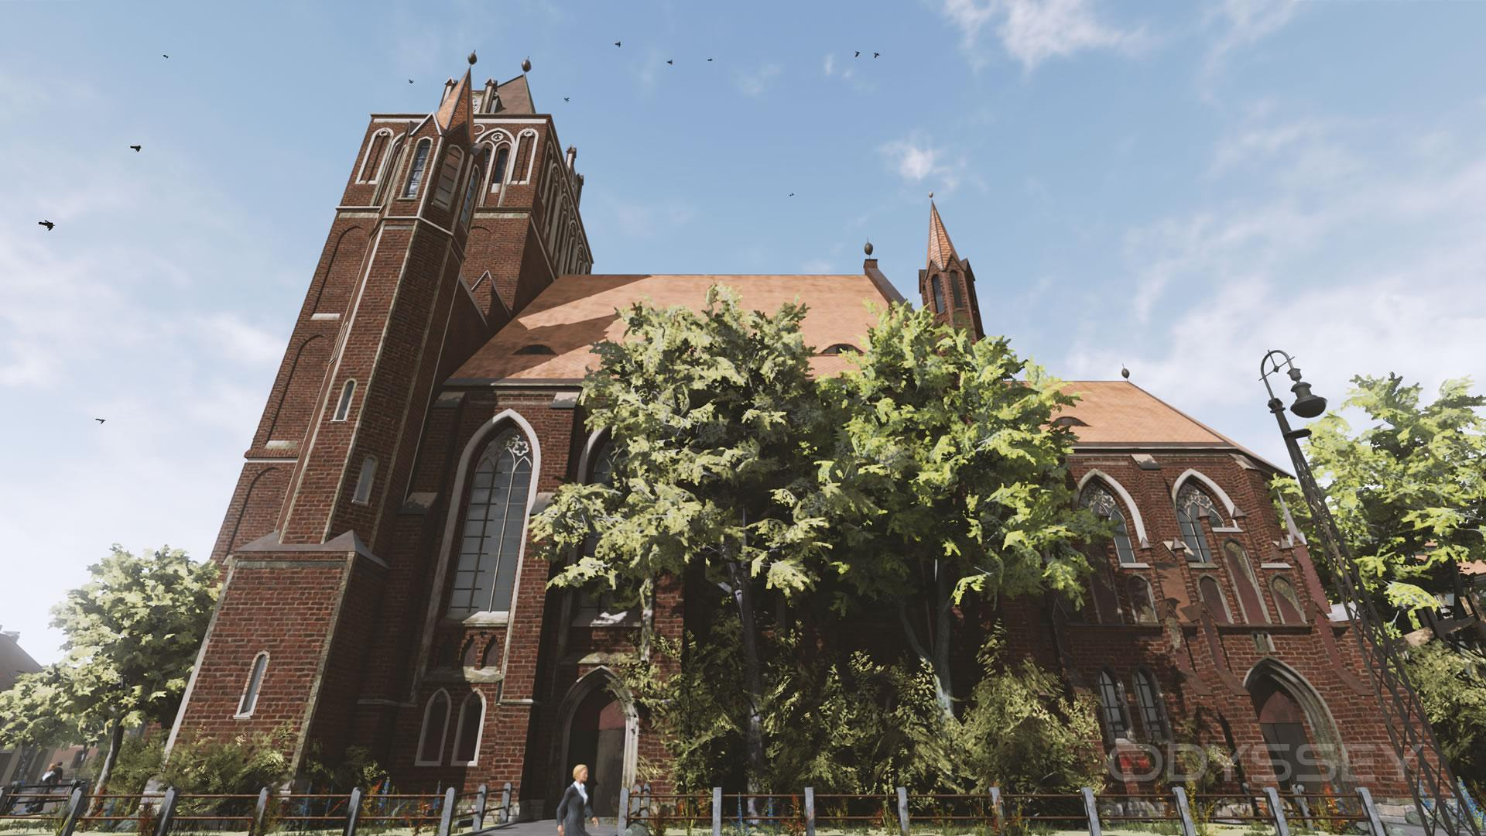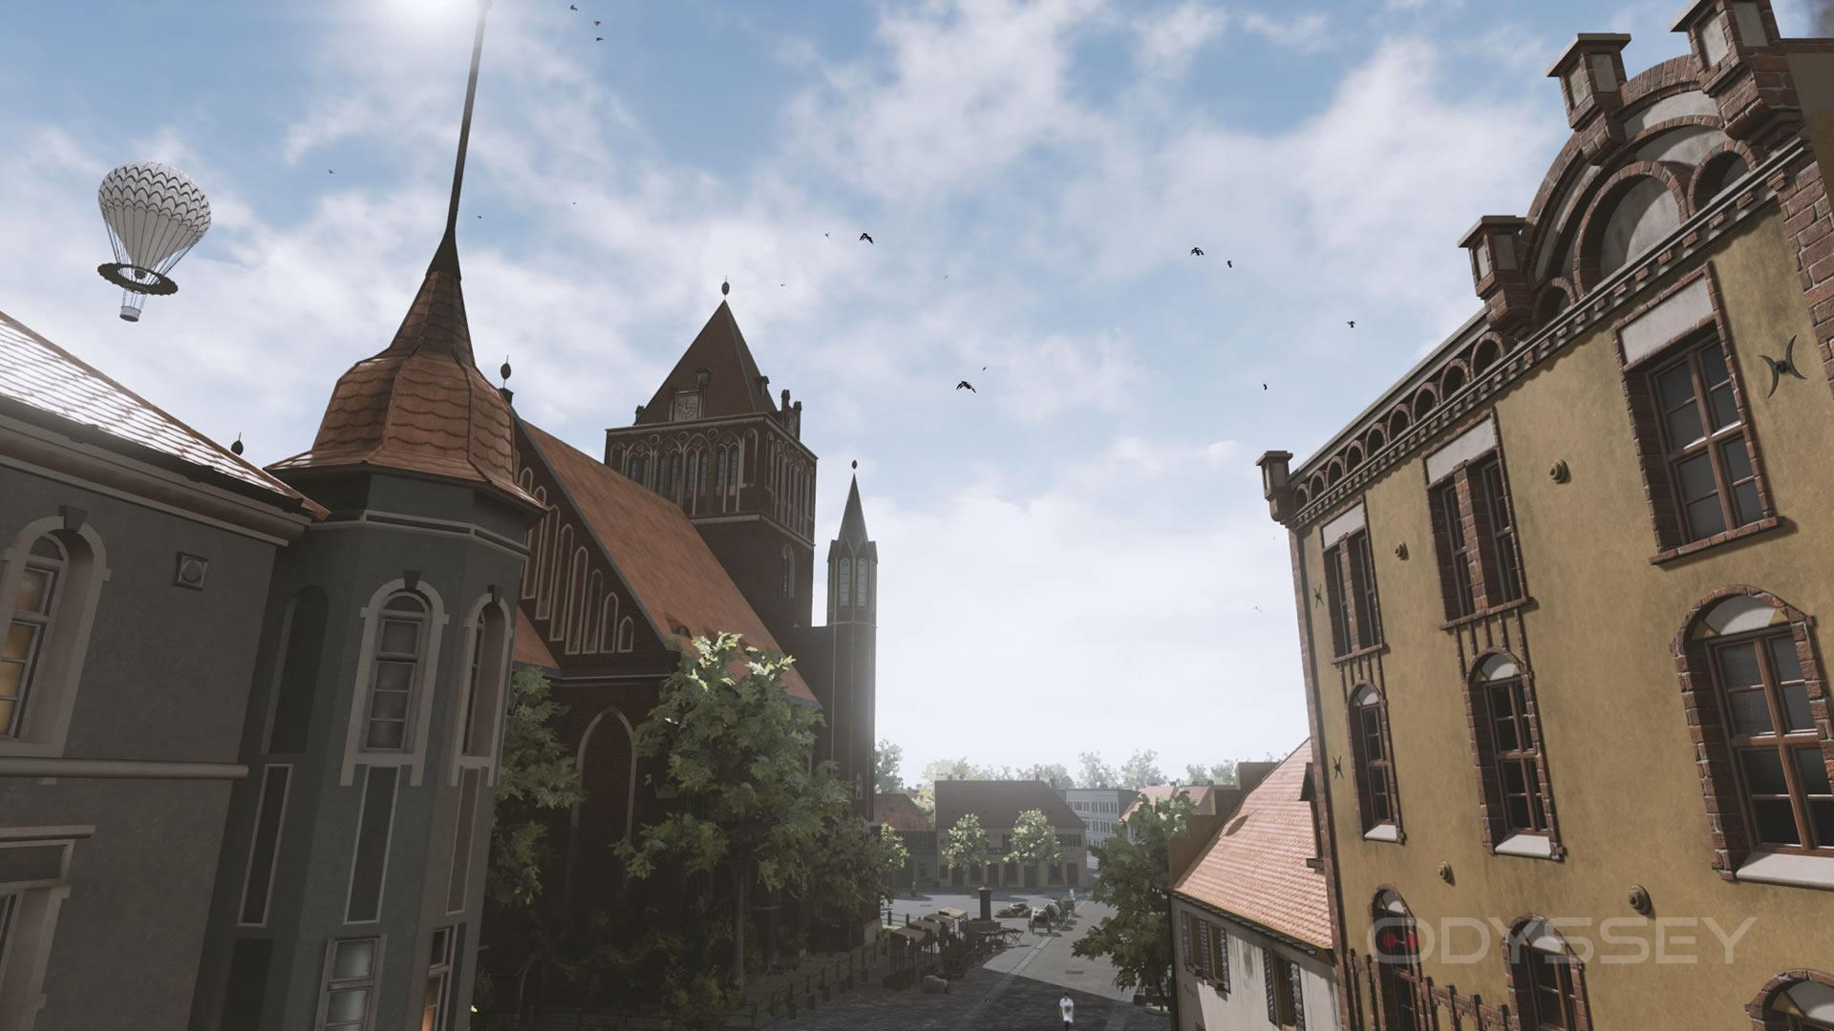

**Figure 1**: Screenshots of Arnswalde VR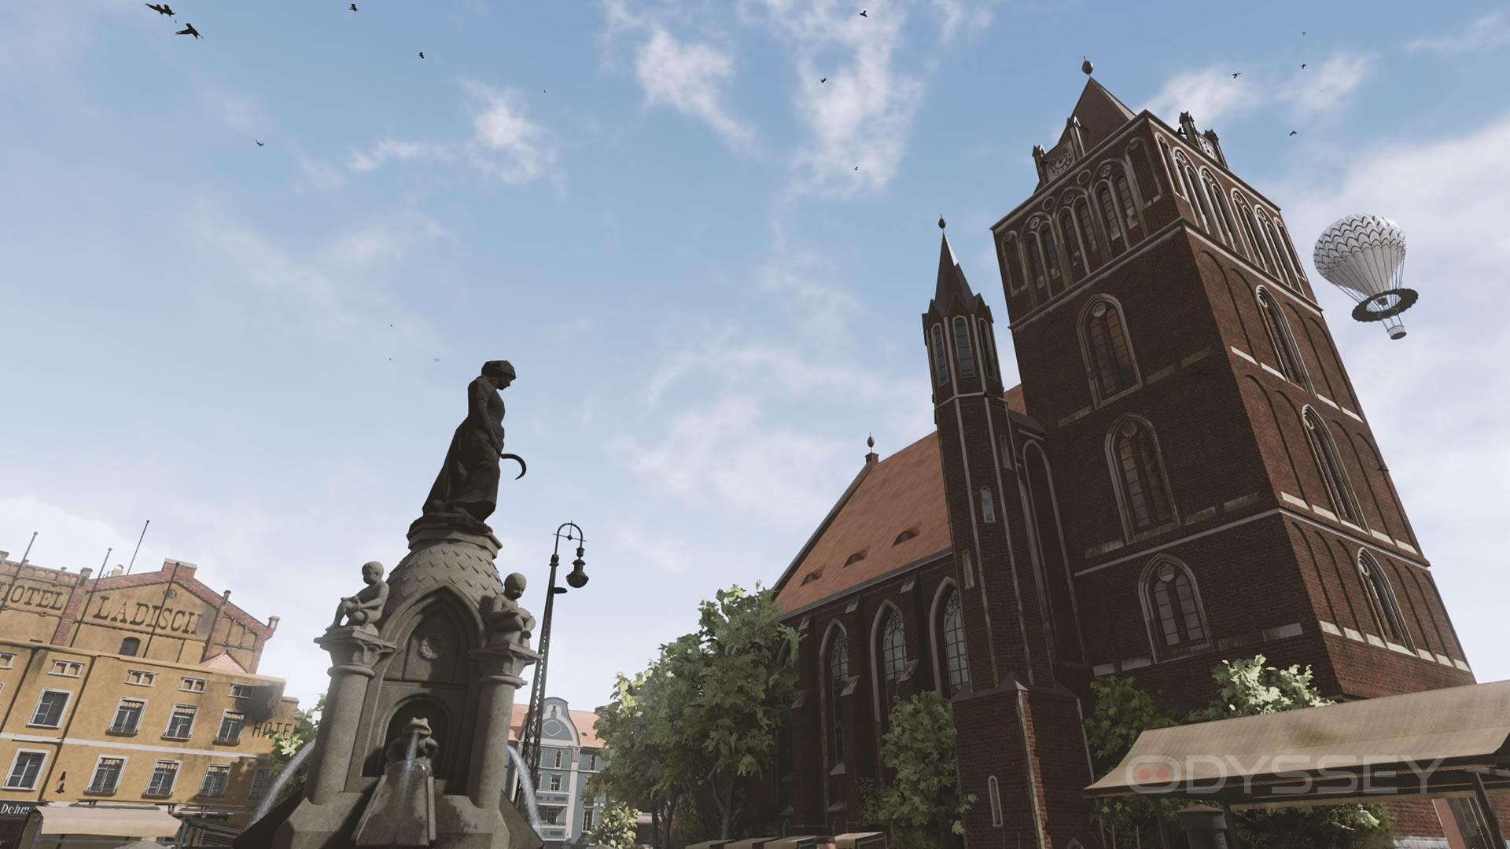

**Source**: [**https://www.roadtovr.com/preview-arnswalde-vr-memorial-life-ww2**](https://www.roadtovr.com/preview-arnswalde-vr-memorial-life-ww2/)

**Wanderer**

Wanderer features a story of traveling back to the past to fix the post-apocalyptic present that the game first presents itself as. The story makes one uncover the character’s grandfather’s secret hideout in the ruins of Boston, befriending a talking watch, and then travel back and forth between times as the player is being hunted by space cops that do not want the player tampering with time. This game boasts its ability to realize the potential of time-spanning puzzles and to bring different items to different points of the game, however it falls victim to lengthy exposition and multiple underdeveloped characters [30].

**Figure 2:** Screenshots of Wanderer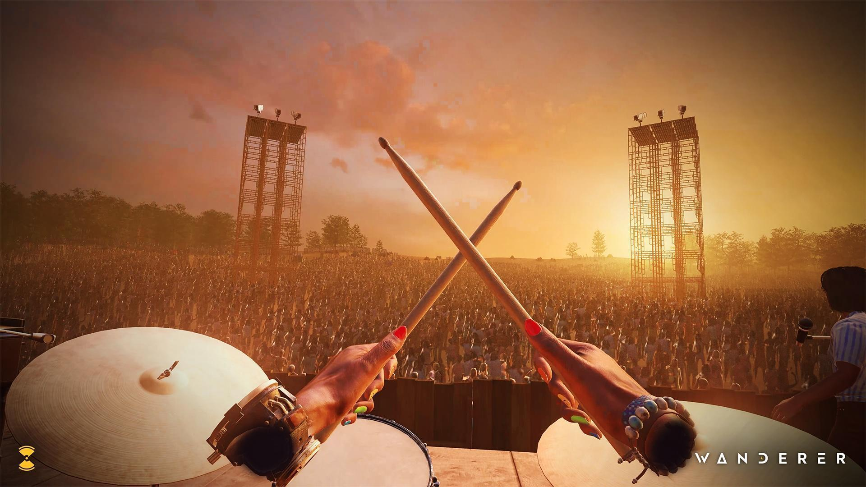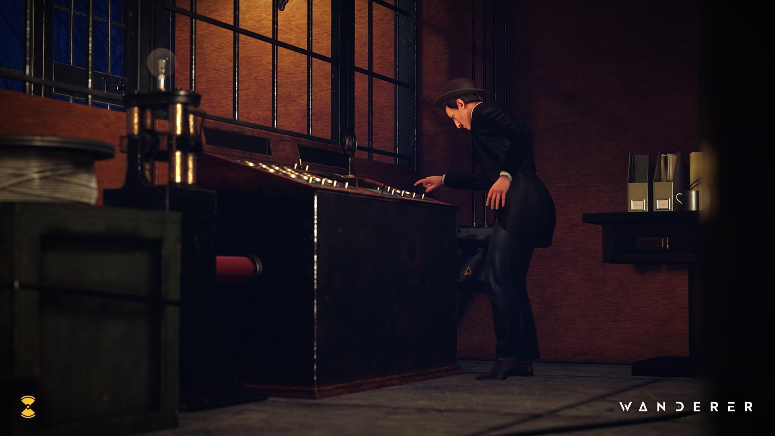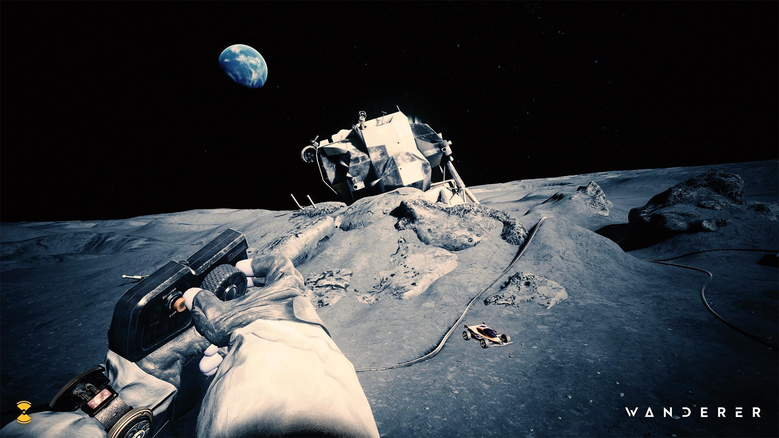

**Source:** [**https://www.gamestar.de/galerien/wanderer_screenshots,135406.html**](https://www.gamestar.de/galerien/wanderer_screenshots,135406.html)

**Brink Traveler**

Teleports the user across the planet and lets one explore breathtaking real-world locations in fully 3D environments created from meticulously scanned photogrammetry and LiDAR technology. It is also completed with immersive 6DOF tracking and a virtual travel guide who narrates the locations as the user explores. The game also included in-game ‘collectible’ points of interest at each of the explorable locations to encourage exploration and as well as a day/night mode to shift the time of day in real-time [31].

**Figure 3**: Screenshots of Brink Traveler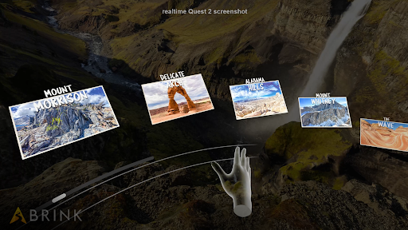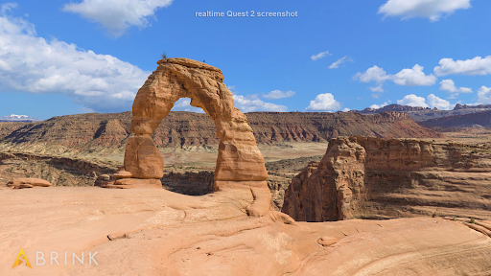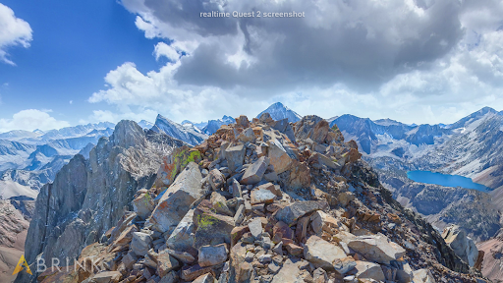

**Source**:[**https://www.meta.com/blog/quest/see-the-world-from-the-comfort-of-home-with-brink-traveler-out-now-on-oculus-quest-and-pc-vr/**](https://www.meta.com/blog/quest/see-the-world-from-the-comfort-of-home-with-brink-traveler-out-now-on-oculus-quest-and-pc-vr/)

**Time Machine VR**

Time Machine VR puts players inside a time traveling pod with tools to help them learn about the creatures of the past as it explains a story of how the world was destroyed in its setting due to a pandemic [32].

**Figure 4**: Screenshots of Time Machine VR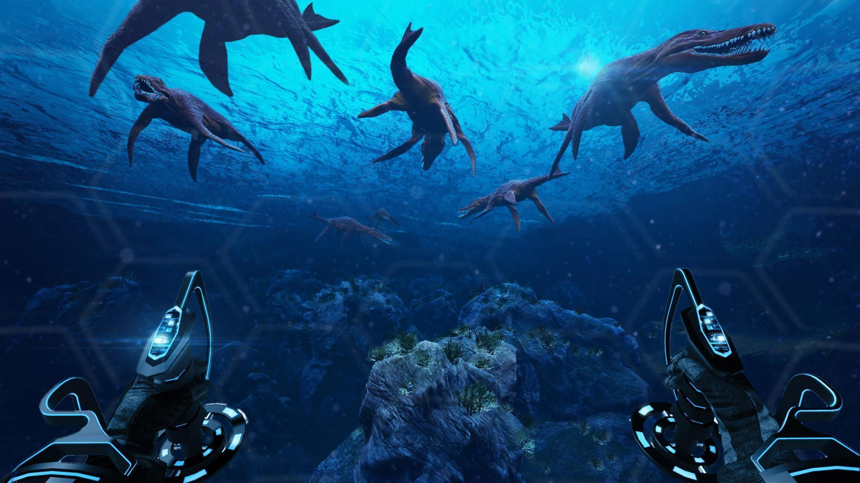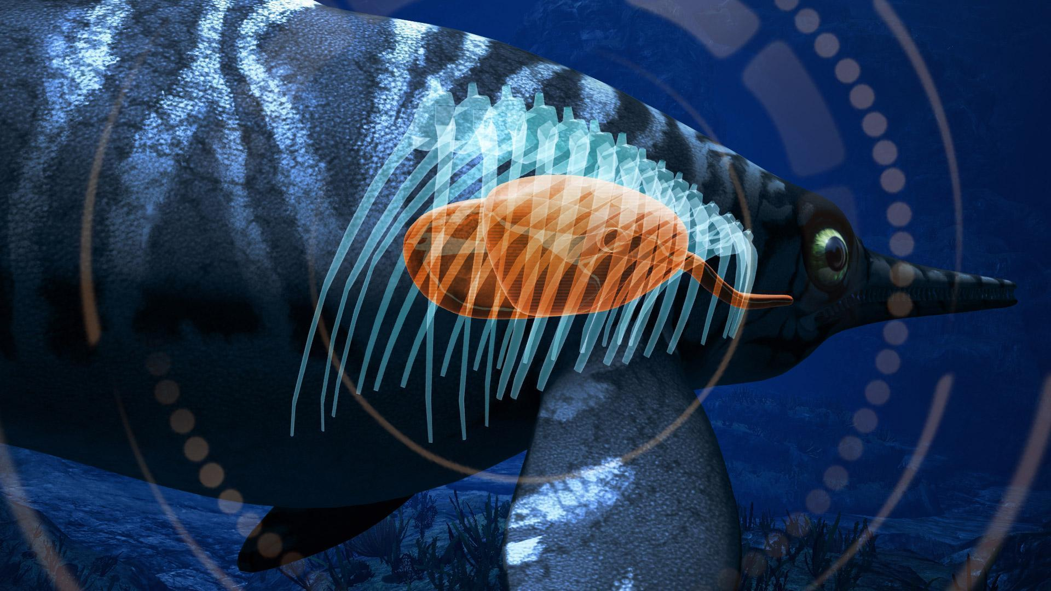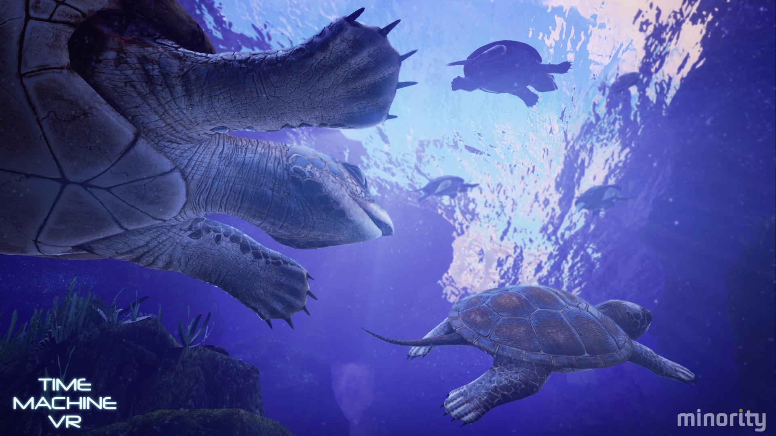

**Source:** [**https://www.roadtovr.com/review-time-machine-vr-htc-vive-steamvr/**](https://www.roadtovr.com/review-time-machine-vr-htc-vive-steamvr/).

**National Geographic Explore VR**

This game allows players to travel to Antarctica and set off on a thrilling expedition of discovery. Players will navigate around icebergs in a kayak, climb icebergs, and survive a raging snowstorm as one searches for a penguin colony. This interactive, 6DOF VR experience is suitable for all ages and can be enjoyed with the entire family [33].

**Figure 5:** Screenshot of National Geographic Explore VR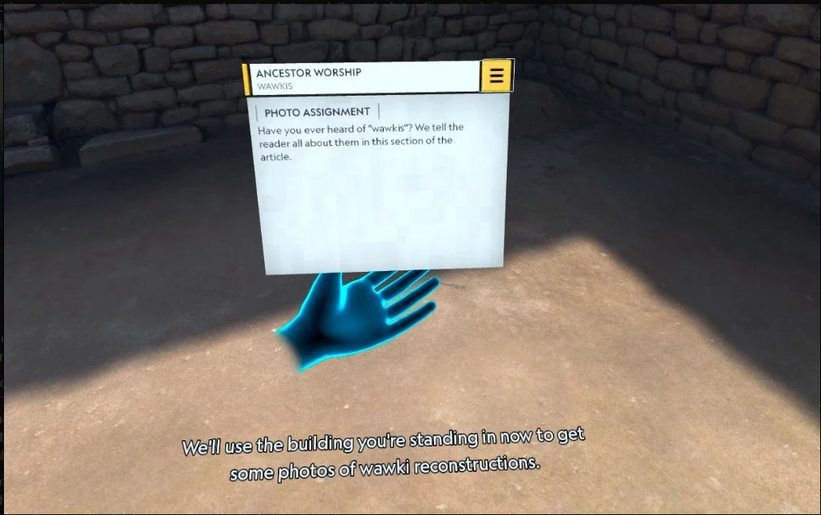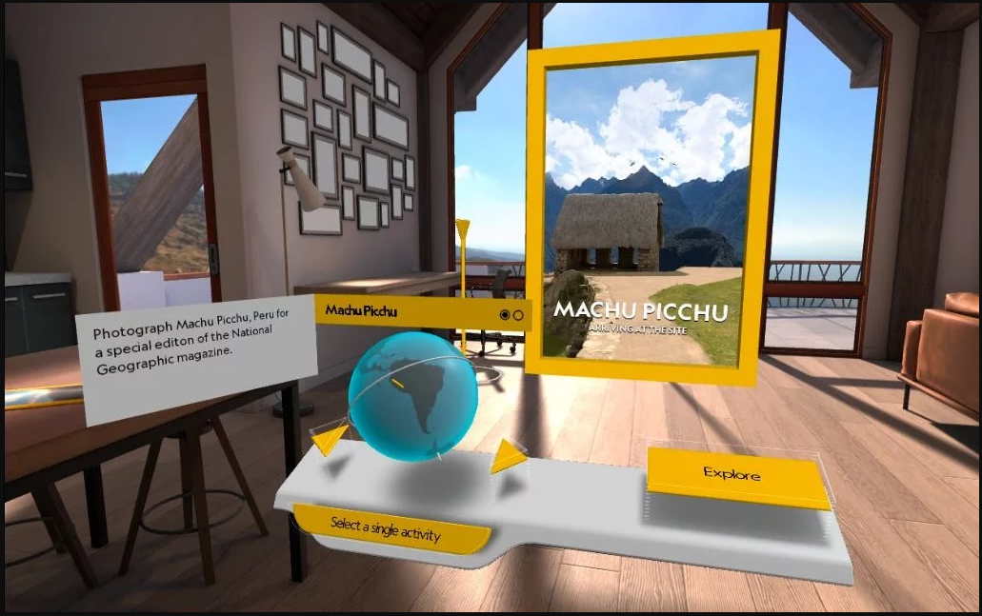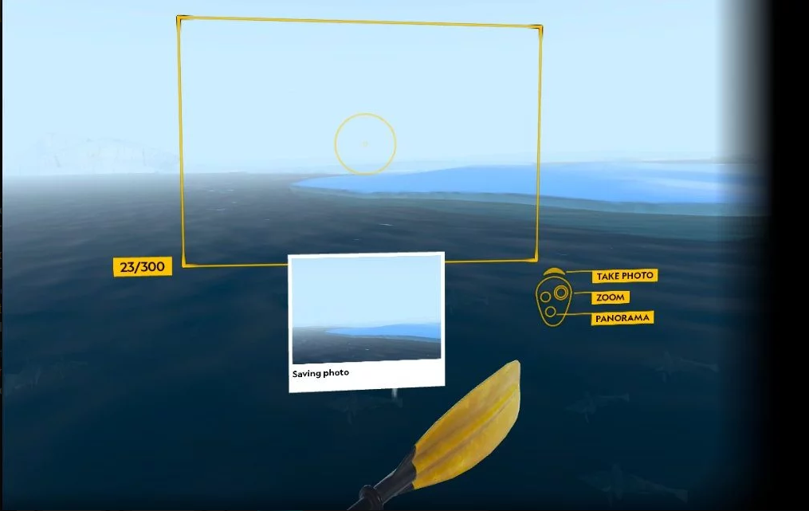

**Source:** [**https://www.vrvoyaging.com/national-geographic-explore-vr/**](https://www.vrvoyaging.com/national-geographic-explore-vr/)**.**

**REVIEW OF RELATED SYSTEM MATRIX**

In this part, a compare and contrast of systems was conducted so that the researchers are able to find out what are the possible strengths and weaknesses of our VR application to the other related system. Figure 6 shows the matrix that the researchers are going to use in comparing each of the related systems to our VR application. This illustrates that the proposed application will cover aspects such as safety, realistic graphics, intuitive controls, good content, interactivity, and storytelling elements. Nevertheless, it does not fall within the low-cost category due to the advanced equipment required to simulate and create a virtual reality environment.

| **VR Applications** | **Safety** | **Realistic Graphics** | **Intuitive Controls** | **Low Cost** | **Good Content** | **Interactivity** | **Storytelling** |
| --- | --- | --- | --- | --- | --- | --- | --- |
| Arnswalde VR | **✓** | **✓** |  | **✓** | **✓** | **✓** | **✓** |
| Wanderer | **✓** | **✓** | **✓** |  | **✓** | **✓** | **✓** |
| Brink Traveler | **✓** | **✓** | **✓** |  |  |  |  |
| Time Machine VR | **✓** | **✓** | **✓** |  | **✓** | **✓** | **✓** |
| National Geographic Explore VR | **✓** | **✓** | **✓** |  | **✓** | **✓** |  |
| VR MMSU Chronicles | **✓** | **✓** | **✓** |  | **✓** | **✓** | **✓** |

**Figure 6.** VR Related System Matrix

**Conceptual Framework**

In this section, the proponents implemented the conceptual framework’s IPO (Input-Process-Output) paradigm. The Input consists of the variables that were used to meet the project result. These inputs are: (1) development tools; (2) requirements for developing a VR app; and (3) gathered information - literature review, related systems, and MMSU’s presidents and history.

The processes involved in this project are: (1) collect necessary information for users to learn the MMSU’s history; (2) determine the requirements needed for the VR application; (3) develop a VR app that will educate users based on the information gathered; and (4) determine the level of acceptability for VR users. The output of this project is VR Chronicles: VR Game Time Capsule of MMSU History.

| Input | Process | Output |
| --- | --- | --- |
| * Development Tools * VR App Requirements   Gathered Info:   * Literature Review * Related Systems * MMSU’s Presidents and history | * Collect necessary information for users to learn the MMSU’s history * Determine the requirements needed for the VR application * Develop a VR app that will educate users based on the information gathered; * Conduct user acceptance level testing | **MMSU VR CHRONICLES: A VIRTUAL REALITY GAME TIME CAPSULE OF THE HISTORY OF MARIANO MARCOS STATE UNIVERSITY** |

**Figure 7.** Conceptual Framework

**METHODOLOGY**

This part presents the methodology that the researchers have used during the conduct of the research. This covers the data gathering tools and software development methodology that the researchers are going to use as they continue with their project.

**Research Design**

The proponents used descriptive research to collect the information necessary for the project. The researchers gathered information about the historical moments in MMSU by visiting the MMSU library and museum to gather the necessary documents and information. The researchers also gathered pictures of the presidents and buildings so that they could recreate a more realistic virtual environment and characters for the game. Finally, the researchers determined the necessary requirements for developing the virtual environment and characters of the VR game through reading materials and watching tutorials about it.

**Data Gathering Tool**

The project took place at the Mariano Marcos State University, City of Batac, Ilocos Norte. Using descriptive as the research method, the researchers collaborated with the MMSU museum to gather information about the historical moments focused on the diorama in the university’s museum and obtained a copy of pictures of the presidents and information about the presidents and events. Following the development of the system, the proponents conducted a user acceptance test (UAT) survey, aligning with the software quality standards outlined in ISO/IEC 25010. Interested students at MMSU Batac Campus, gathered through purposive sampling, participated in testing the application.

**Data Gathering Procedure**

The proponents conducted a user acceptance test after they developed the VR application to determine its user acceptability in terms of the VR applications functionality, interactivity, efficiency and reliability. The purposive sampling method was used for the conduct of the survey. The respondents were undergraduate students and the museums in-charge of Museo MMSU from the University Library. They were asked to evaluate the VR application using a survey form. The data that the researchers gathered in the survey was used to check if some qualities of the VR application were lacking so that the proponents could fix them. The interpretation of the collected data was based on the scale outlined in Table 3.

**Table 1**. Scale to Measure Users’ Acceptability

| **Weighted Mean Average** | **Interpretation** |
| --- | --- |
| 4.20 - 5.00 | Strongly Agree (SA) |
| 3.40 - 4.19 | Agree (A) |
| 2.60 - 3.39 | Moderately Agree (MA) |
| 1.80 - 2.59 | Disagree (A) |
| 1.00 - 1.79 | Strongly Disagree (DA) |
|  |  |

**3D Modeling Procedures**

**Virtual Human Modeling Process**

The following figure shows the steps the researchers followed several steps in creating their virtual characters for the VR application. First, they gathered pictures of presidents from the MMSU Museo to ensure the integrity of the models. Using these references, the researchers created the 3D models in Blender. After forming the basic shapes of the faces, they cleaned the mesh and exported them as .fbx files. These files were then imported into Unreal Engine where key parts of the face were mapped. The researchers further refined the mesh and added realistic features using the MetaHuman plugin in Unreal Engine. Finally, they used the OpenCV library to detect similarities between the created mesh and the reference pictures, ensuring an at least 60% accuracy in the virtual characters.

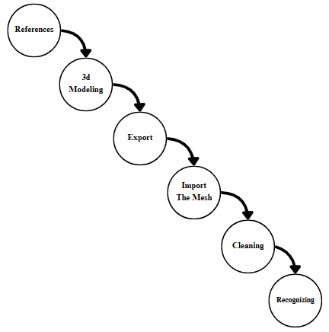

**Figure 8.** Virtual Human Modeling Process

**Virtual Environment Modeling Procedure**

The following figure shows the process the researchers followed in creating virtual environments for the VR application. First, they gathered pictures of the dioramas from the MMSU Museo to use as references for each stage of the virtual environment. Using Blender, they created the base shapes for the initial virtual environment. Once the 3D model was completed, it was exported as an .fbx file. These files were then imported into Unreal Engine to construct the virtual environment for each stage of the game. The researchers then proceeded to cut and reshape the imported models to design the interior of the virtual environment. The researchers then added foliage such as grass, trees, and rocks to enhance realism. Finally, they added additional objects, like chairs, to provide more detail to the VR application.

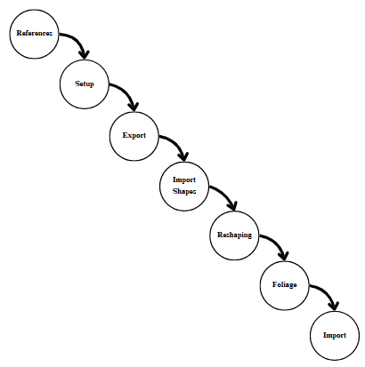

**Figure 9.** Virtual Environment Modeling Procedure

**Population and Sampling**

To obtain a sample that appropriately suits the project’s objective, purposive sampling was used, targeting individuals who expressed their interest in the following criteria: 1.) Those who are interested in learning the history about the foundation of the university; and 2.) If they would be willing to see the information mentioned in VR (Virtual Reality). An initial survey was distributed to identify 26 students with the mentioned criteria, asking them their interest in participating in the project. Additionally, 18 other individuals who witnessed the testing of the project and were equally interested and met the criteria were included in the respondents from the initial survey.

This approach ensures that the sample includes students with strong interest in learning history, providing insights into the effectiveness of the use of VR (Virtual Reality) as a tool in learning the history of the university.

**Software Development Methodology**

Figure 10 shows the Scrum Development Methodology, an agile development Methodology, which is constructed of five phases: Product Backlog, Sprint Planning, Sprint, Sprint Review, and Sprint Retrospective. This iterative sequence of tasks helped the development team to consistently provide value to stakeholders and users, take in feedback and keep making the product and development process better.

In the initial product backlog one phase, the proponents read and reviewed the related literature and the related systems, the proponents also read literature about the development of Virtual Reality, 3D modeling, and game development. Additionally, a research and interview were conducted with the museum in-charge for information about the history of MMSU and highlighted projects of each Presidents.

During the sprint planning phase, a meeting with the team was conducted to form ideas from the initial product backlog phases together with the discussion of implementation tools, development, and modeling. A list of functional requirements was also implemented, along with the VR Environment layout, user interfaces, and use case diagrams.

In the sprint review phase, the development team demonstrated the completed work to users and gathered feedback. The product backlog was updated after this phase based on the gathered feedback.

The final phase was the retrospective phase. The product was tested by the overall functionality of VR to determine if all the requirements were met. With this test, the team knew what areas were working efficiently and what areas were lacking. The process was repeated until the product was complete.

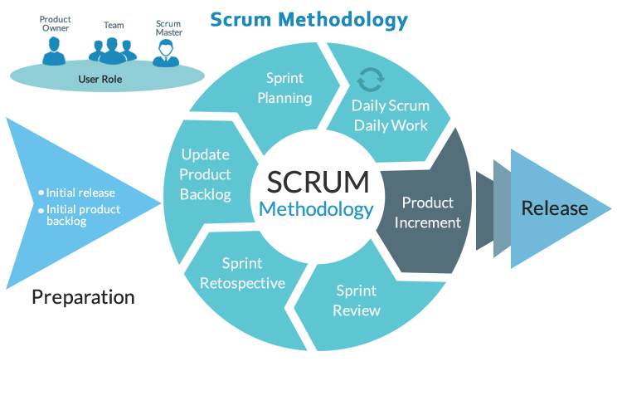

**Figure 10.** Scrum Development Methodology

**Source:** [**https://www.covetus.com/blog/scrum-methodology-agility-with-endurance**](https://www.covetus.com/blog/scrum-methodology-agility-with-endurance).

**RESULTS AND DISCUSSIONS**

This section presents the results of the project. This includes the discussion of the system designs and requirements, and interpretation of the user acceptance test results.

**Initial Survey for Sampling**

An initial survey was conducted to determine eligibility criteria for the User Acceptance Test (UAT) session through direct communication. A purposive sampling method was used to target the individuals who will be appropriate in achieving the project’s objective.

Figure 11 shows that out of 30 respondents of the survey, 87% percent showed interest in learning the history of MMSU, specifically its foundation while the other 13% said otherwise.

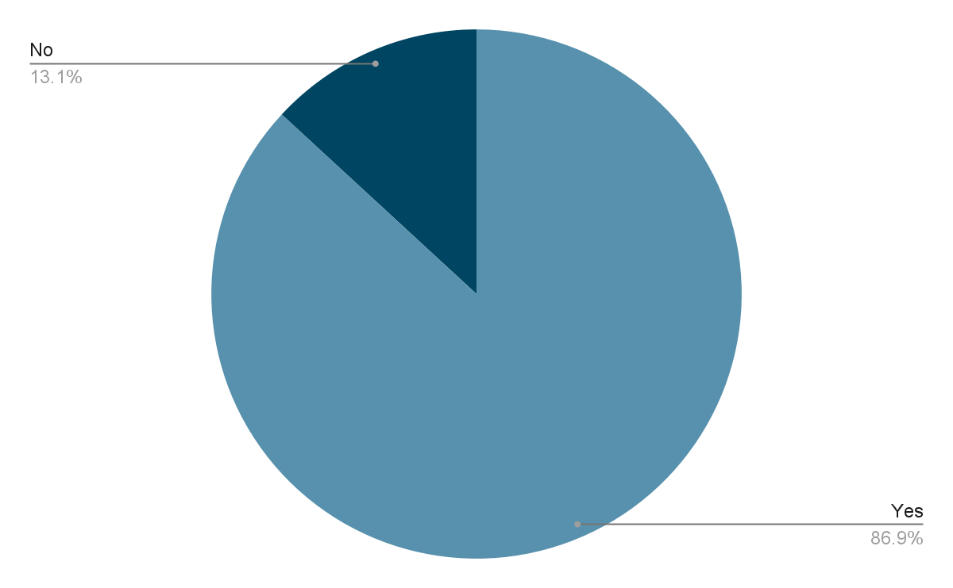

**Figure 11**. Percentage of Individuals Interested in Learning MMSU’s History

Figure 12 showcases the percentage of the respondents who have visited the dioramas which showed the basic information of the notable events that happened in the university’s history. 83% of the respondents have not yet seen the dioramas which supports the museum’s statement that there is less foot traffic in where the dioramas are located while 17% of the respondents said that they have.

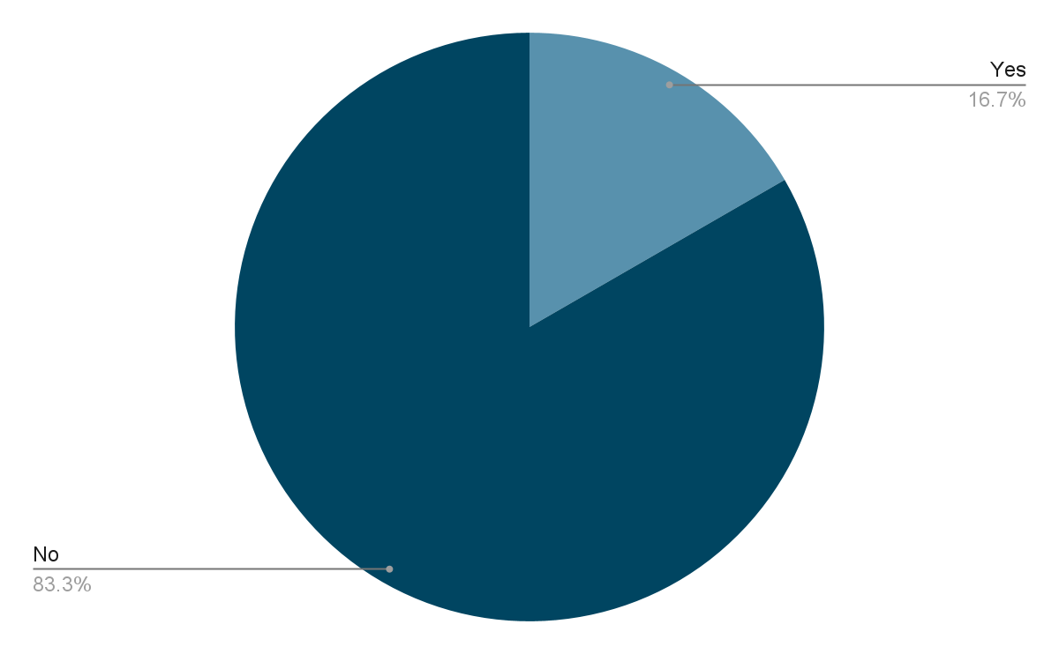

**Figure 12**. Percentage of Who Visited the Dioramas at MMSU Museo

Figure 13 presents the percentage of individuals with experience in using Virtual Reality. 73% of the respondents answered they had no prior experience with virtual reality and virtual reality tools.

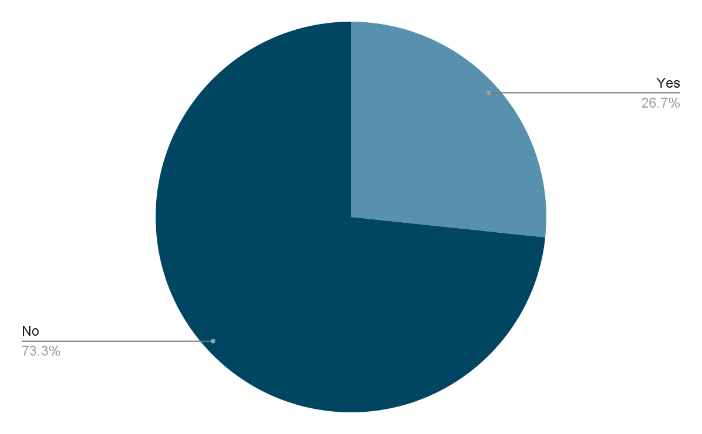

**Figure 13**. Percentage of Individuals with Experience in Virtual Reality

However, it is also shown in Figure 14 that despite their inexperience with VR platforms, most of the respondents would like to experience VR and its immersive capabilities as well as the history of the university through the said platform.

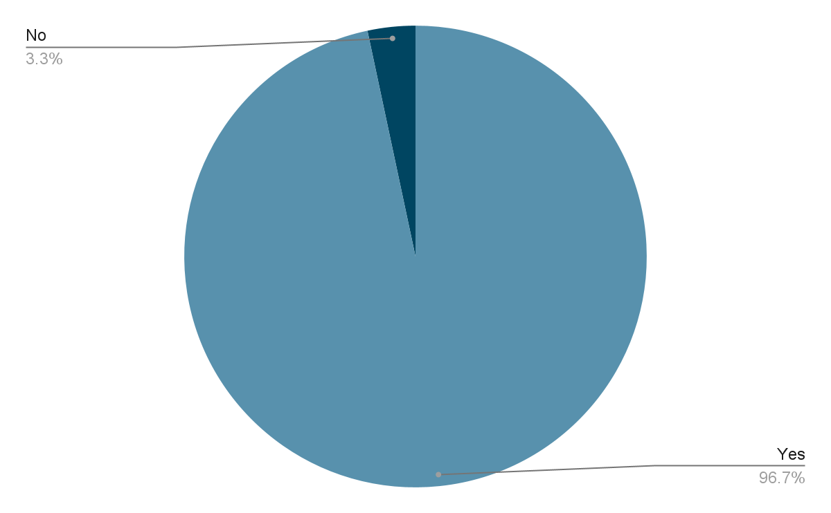

**Figure 14**. Percentage of Individuals Interested in VR and MMSU History in VR

With the data gathered from the survey, a strong interest among the respondents was noticed about the history of MMSU, with 97% of the initial respondents indicating their desire to do so. Additionally, an overwhelming majority of 97% of the respondents expressed an interest in experiencing history through Virtual Reality (VR) technology. These findings highlight a demand for immersive historical education experience among the surveyed audience.

**Requirements Documentation**

The requirements documentation discusses the logical designs used by the proponents in developing the needs for the accomplishment of this project.

**Logical Design**

The use case diagram shown in Figure 15 presents the functionalities of the VR application, illustrating the interactions between the user and the system.

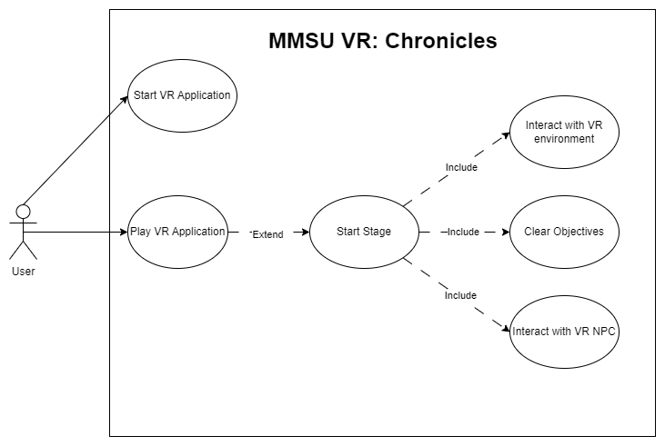

**Figure 15**. Use Case Diagram of the VR Application

The user can interact with the application with the two main functionalities of the application: start, and play. A user must start the VR application to enter the VR world space. Customization of the application’s settings can be done to adjust brightness and volume to users’ preferences. Upon entering the virtual environment, the user will be prompted to enter the first stage of the application to experience the story of the dioramas from start to finish. The user will be required to complete tasks like completing puzzles and interacting with non-playable characters (NPCs) to continue the flow of the game.

**Design Documentation**

**Deployment Architecture**

Figure 16 depicts the deployment architecture of the system, where the users will utilize the Meta Quest 2 to play the game but utilize their own pc to run the game.

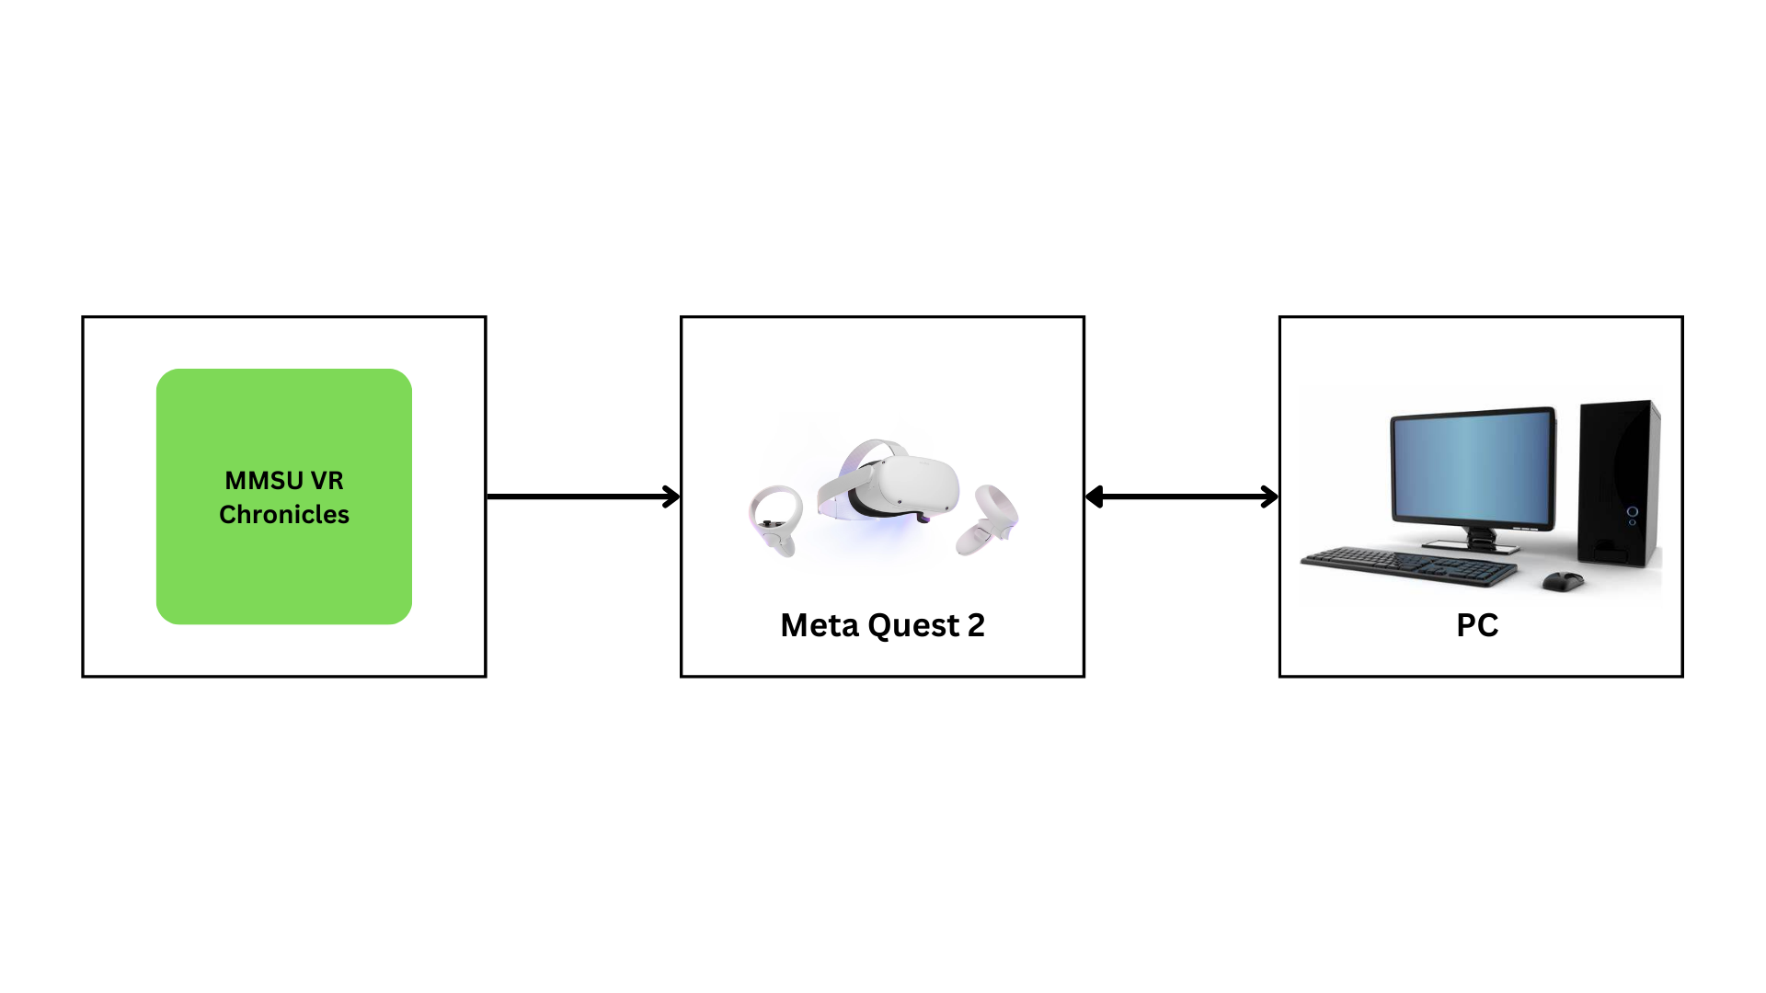

**Figure 16**. Deployment Architecture

**Development Architecture**

Figure 17 shows the development of the system which shows the main tools used to build the application. 3D models for the objects and the face shapes of the presidents were created with the Blender. The face shapes were imported in Unreal Engine to clean the mesh and added features for a more realistic face using the MetaHuman plug-in in the Unreal Engine application. 3D models for the objects and buildings were added into the Unreal Engine and added colors and textures to add more realism to the objects, together with foliage for the virtual environment. For the hardware tools, an ASUS TUF Laptop with a GPU of NVIDIA GeForce RTX™ 3060 and Ryzen 7 processor was used for development. Meta Quest 2 was used for viewing the VR application.

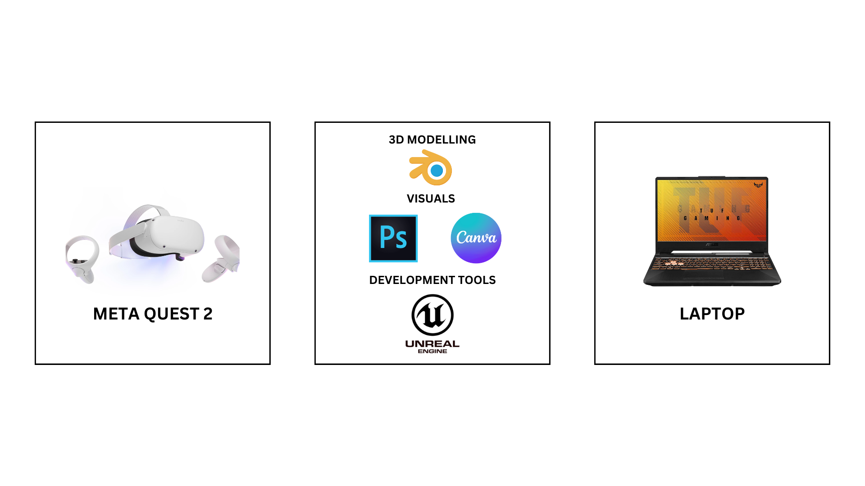

**Figure 17**. Development Architecture

**Application Interface**

The design of the MMSU VR Chronicles application renders a virtual environment presented in the museum’s diorama. The following figures are the screenshots of the user interfaces and virtual environment seen in the application.

Figure 18 displays the initial environment after launching the application. There are widget buttons shown at the right that can be interacted with when the player is nearby.

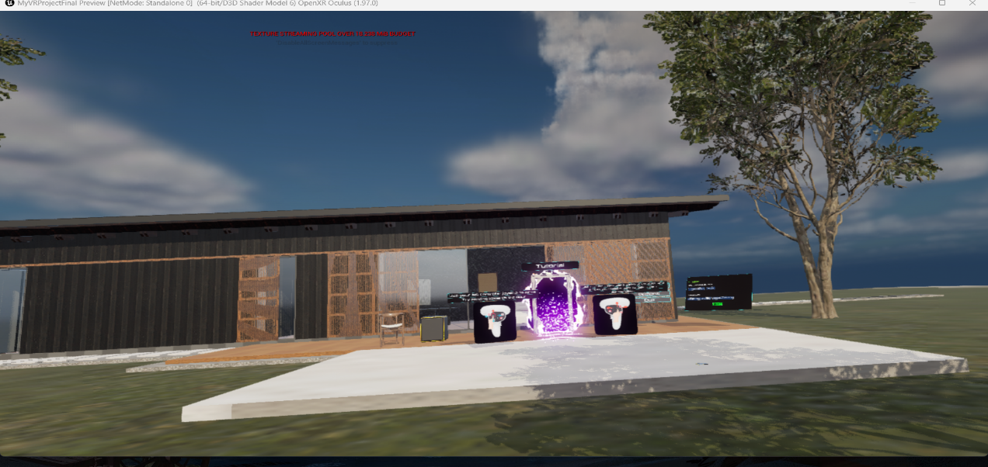

**Figure 18**. Lobby

Figure 19 shows the widget that shows how to move using the controllers with the MetaQuest 2. Ahead shows the door to the tutorial room to show more advanced controls.

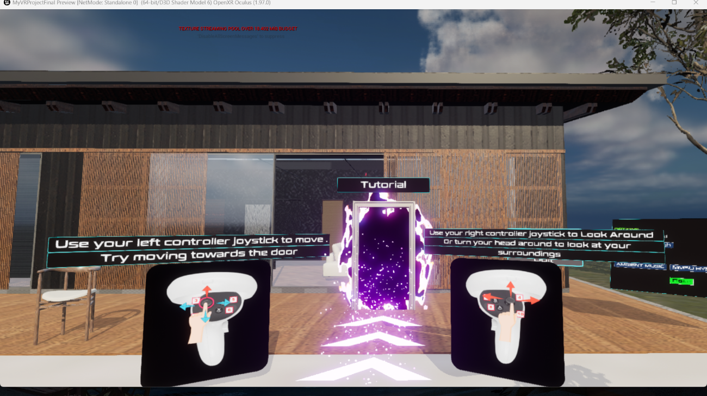

**Figure 19**. Control Instruction Widget

Figure 20 shows a sample objective panel that can be seen when prompted using the controller. A check will show if the specific task is done for the stage.

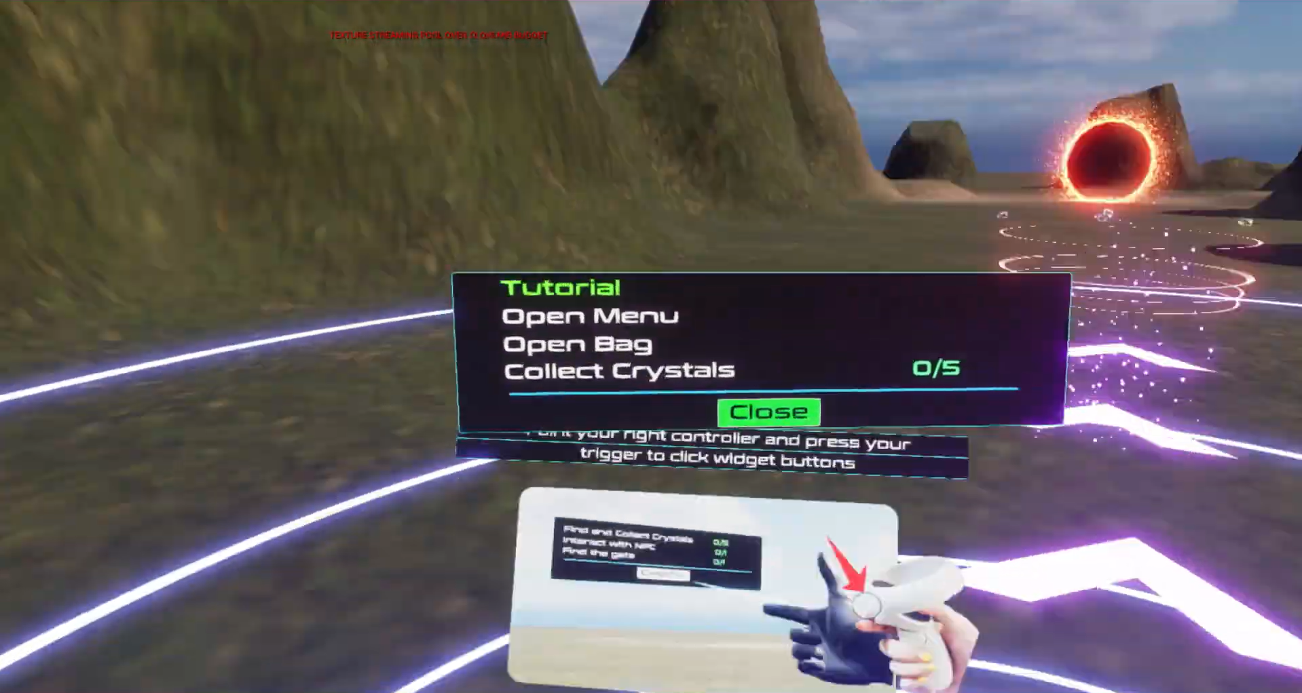

**Figure 20**. Objectives Widget

Figure 21 shows the widget for further instructions when using the controller. Ahead, the player can choose to be teleported back to the start of the game.

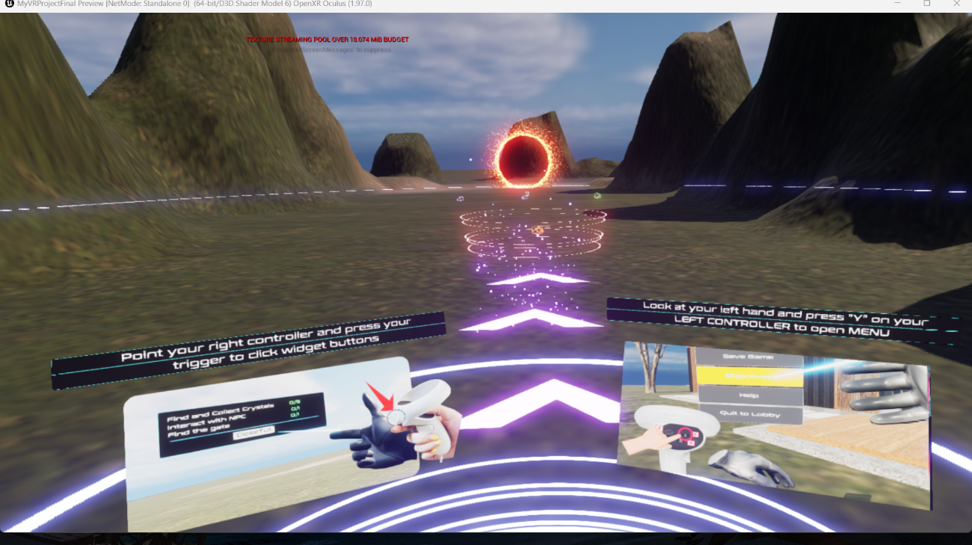

**Figure 21**. Other Controls Widget

Figure 22 shows the options widget where the player can control the movement speed of their VR pawn and choose what music to play when playing the game. Beside it are the options for starting and exiting the game.

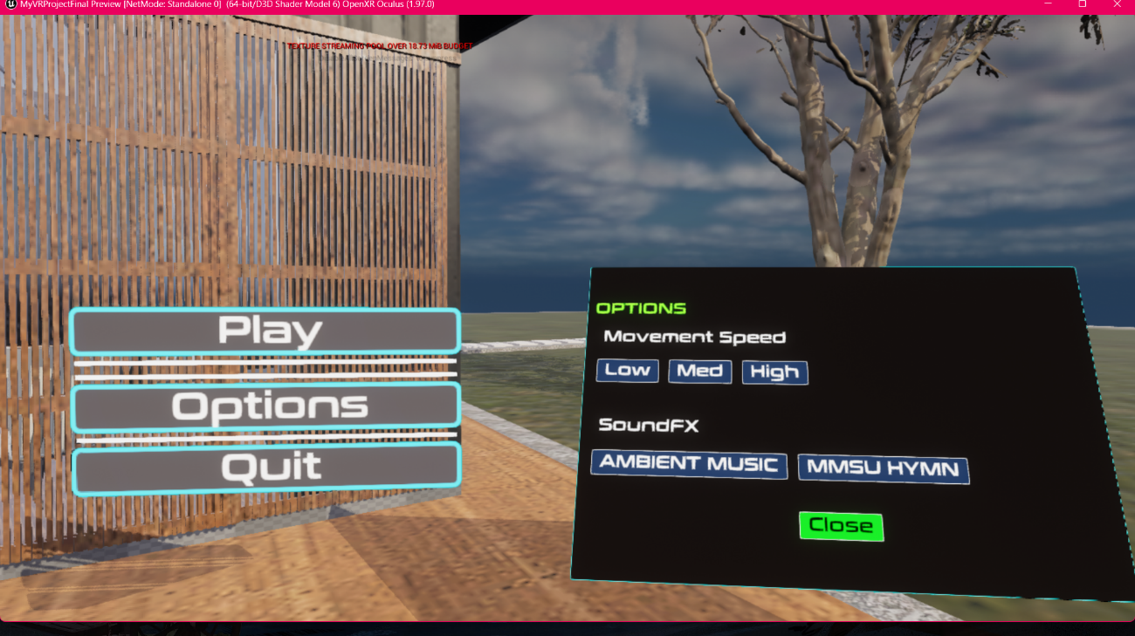**Figure** **22**. Options Widget

Figure 23 shows the environment where the player will see the dioramas the stages are based on and enter through the first stage.

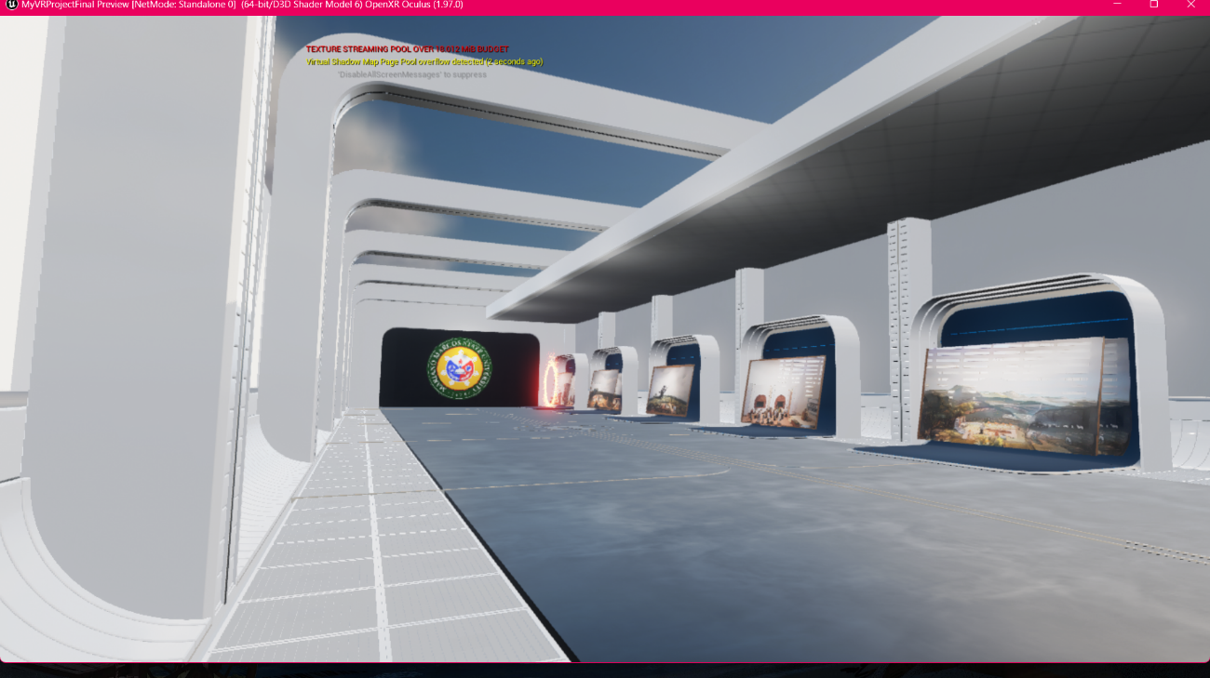

**Figure 23.** Stage Selection

In Figure 24, an interaction with a specific character in the application can be seen to show the basic interface of communication between the player and the character.

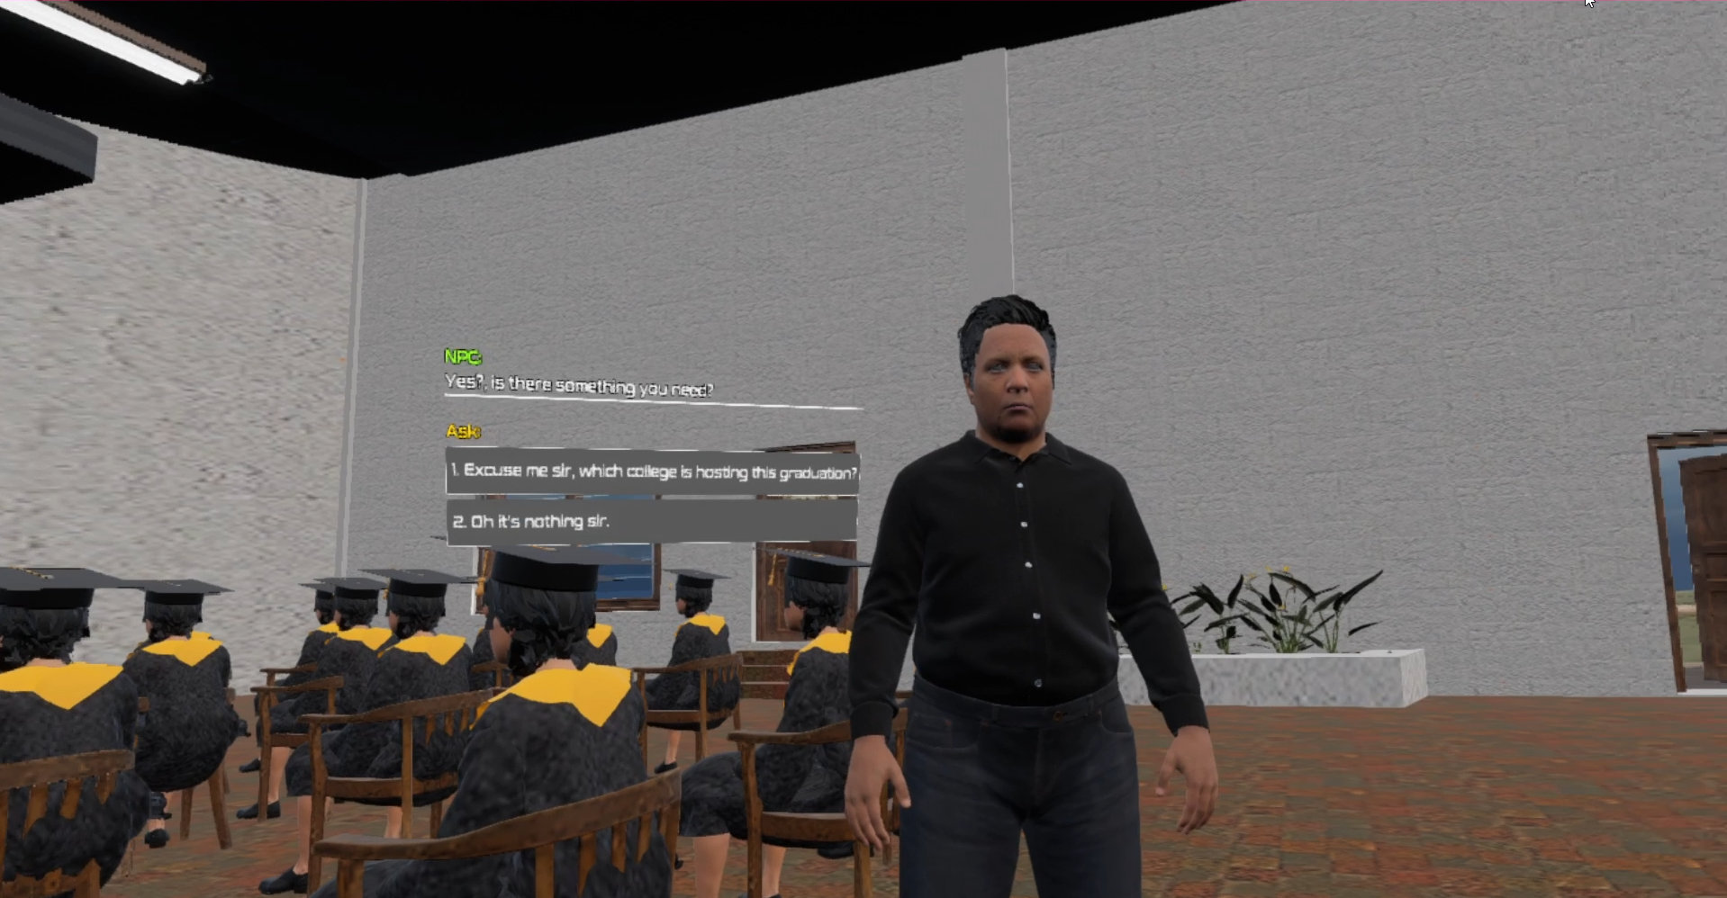

**Figure 24**. Interaction

Figure 25 shows stage 1 of the VR application. The virtual environment presented in the first diorama is rendered here with characters and interaction. Figures 26 to 23 show the next stages that will be rendered after the completion of preceding stages. These visual representations provide insight into the sequence of the application.

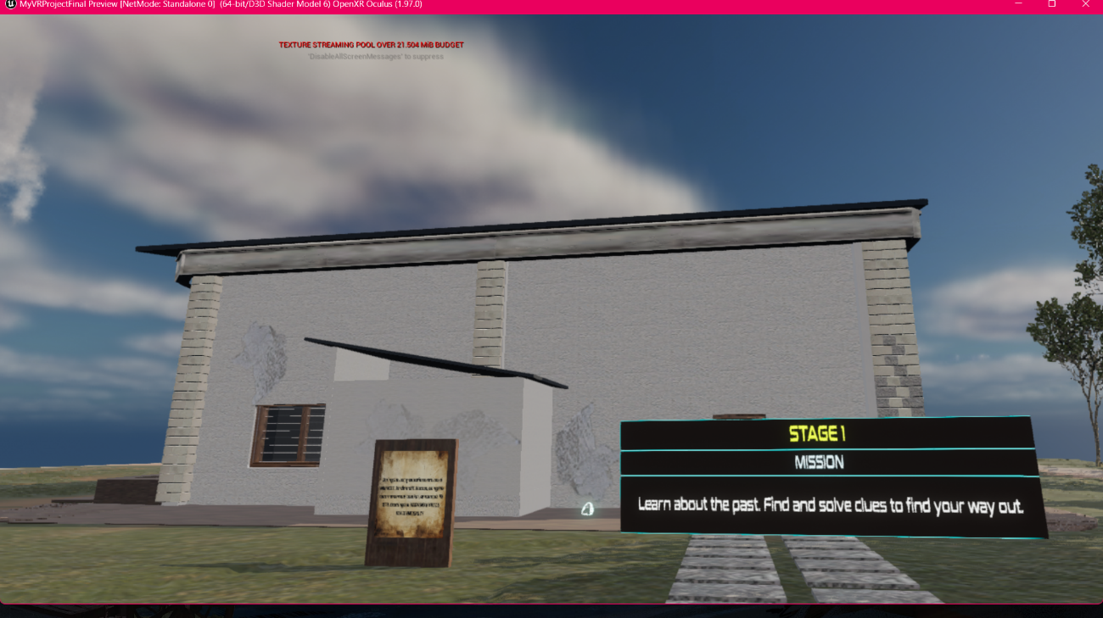

**Figure 25**. Stage 1 Outside

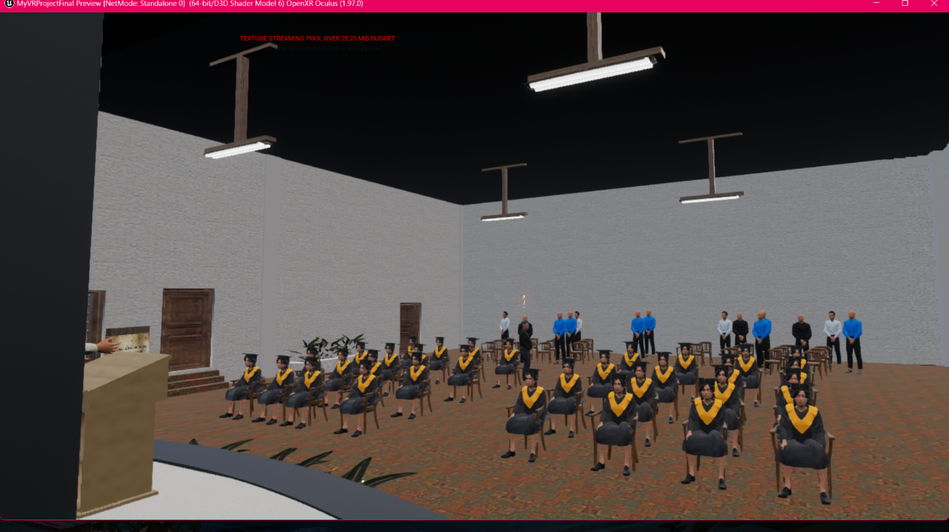

**Figure 26.** Stage 1 Inside

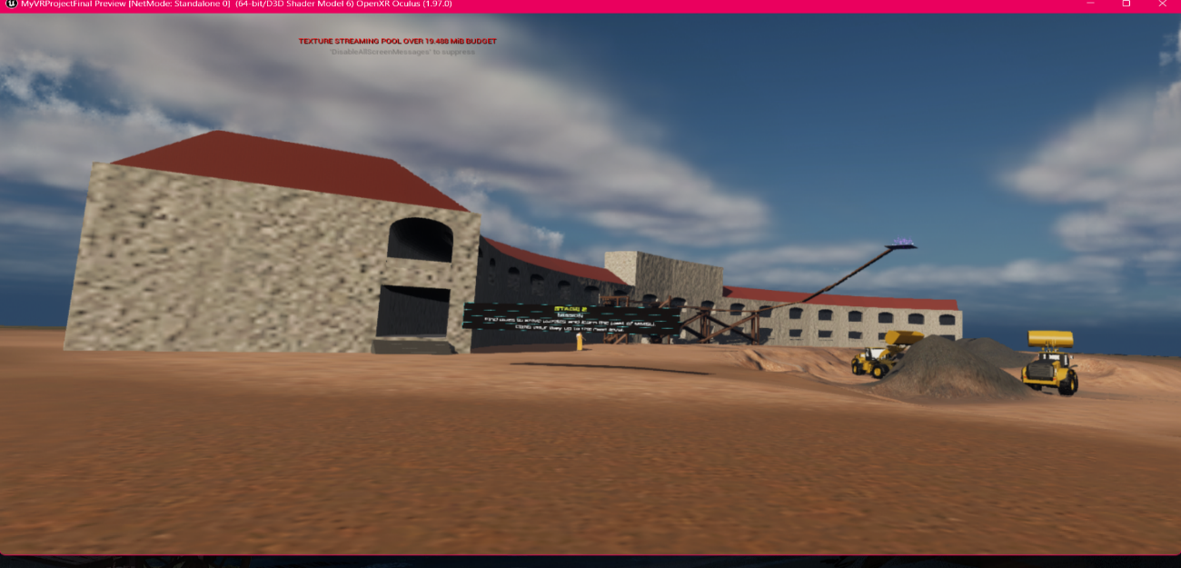

**Figure 27**. Stage 2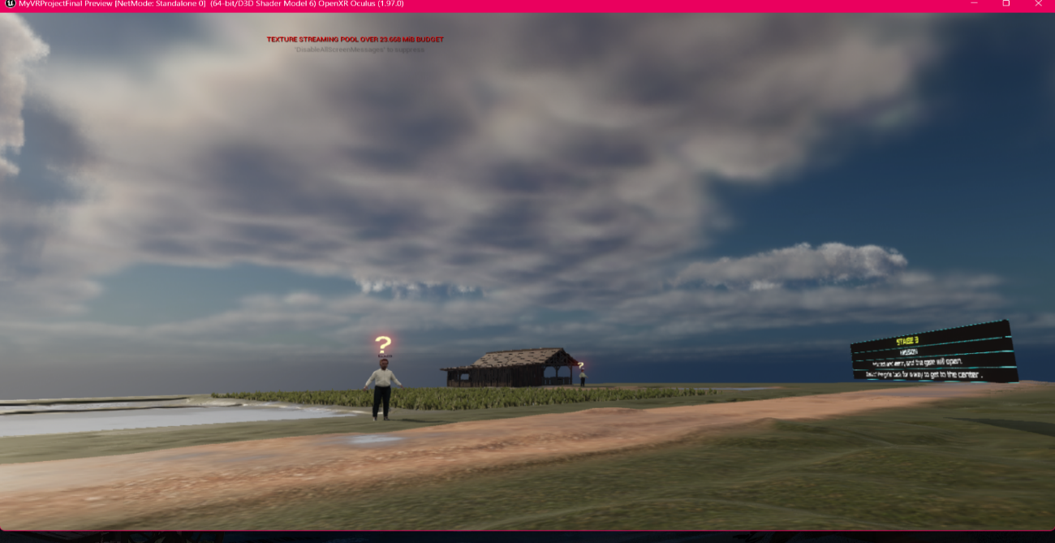

**Figure 28**. Stage 3

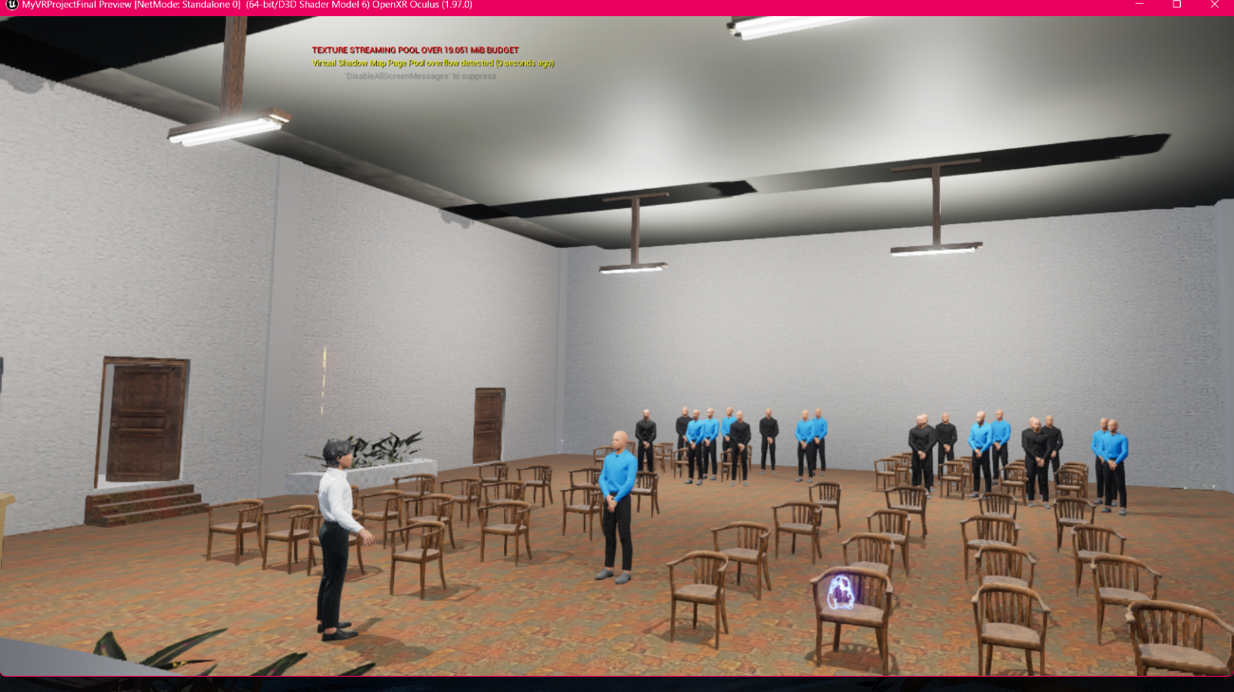

**Figure 29**. Stage 4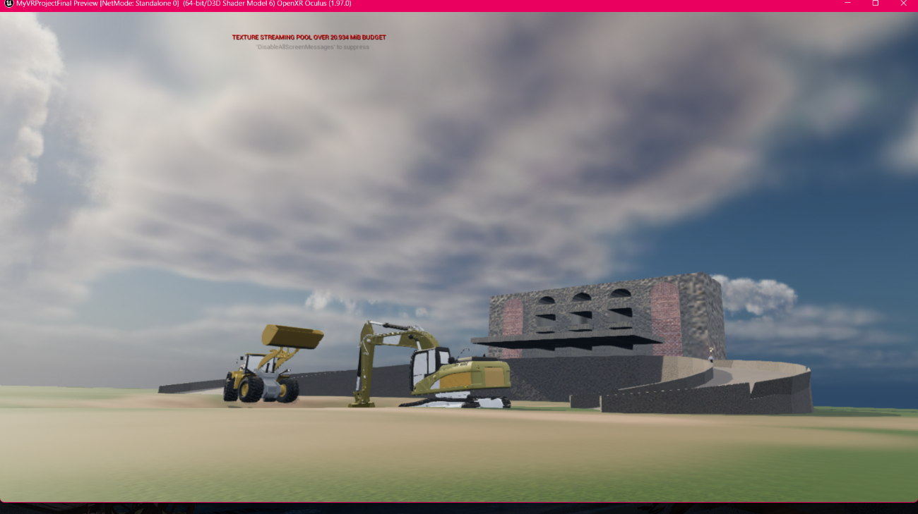

**Figure 30**. Stage 5

**User Acceptance Test**

To find the effectiveness of the application, the researchers conducted a User Acceptance Test. Testing, debugging and revisions are done until all errors are fixed in the application.

Table 4 shows the computed overall mean results from the user acceptance test by the student respondents of the MMSU VR Chronicles. The application obtained an overall mean of 4.55 which meant that the respondents strongly agreed on the functional sustainability, usability, efficiency, reliability, and compatibility of the MMSU VR Chronicles. The respondents also considered the application as “fun and challenging” and as well as “very interactive”. However, it is important to note that some respondents expressed their concerns on the optimization of the application.

**Table 4.** User Acceptance Test (MMSU Students)

| **CATEGORIES** | **MEAN** | **DESCRIPTION** |
| --- | --- | --- |
| Functional Sustainability | 4.61 | Strongly Agree (SA) |
| Usability | 4.5 | Strongly Agree (SA) |
| Efficiency | 4.5 | Strongly Agree (SA) |
| Reliability | 4.45 | Strongly Agree (SA) |
| Compatibility | 4.70 | Strongly Agree (SA) |
| **OVERALL MEAN** | **4.55** | **Strongly Agree (SA)** |

Table 5 shows that the mean reliability was a notable 3.3. This outcome was attributed to the testing equipment overheating during the evaluation process conducted at MMSU Museo. However, the overall mean results from the user acceptance test by the personnel in-charge of the Museo averaged an acceptable score of 4.

**Table 5**. User Acceptance Test (Personnel In-charge of Museo)

| **CATEGORIES** | **MEAN** | **DESCRIPTION** |
| --- | --- | --- |
| Functional Sustainability | 4.42 | Strongly Agree (SA) |
| Usability | 4.11 | Agree (A) |
| Efficiency | 4.17 | Agree (A) |
| Reliability | 3.33 | Moderately Agree (MA) |
| Compatibility | 4 | Agree (A) |
| **OVERALL MEAN** | **4.01** | **Agree (A)** |

**CONCLUSION AND RECOMMENDATIONS**

**Conclusion**

To conclude, the proponents’ endeavor to utilize Virtual Reality (VR) technology into history education, specifically the history of MMSU about its foundation and previous presidents, has unveiled a new landscape for immersive learning. Through research and development efforts, they have identified challenges in traditional teaching methods, including limited engagement, learning passively, and difficulty in retaining core information.

The proponents decided to address these challenges by conceptualizing and developing the MMSU VR Chronicles application. This VR-based application leverages the immersive capabilities of VR to transport the users into historical settings and events, fostering active exploration, deeper understanding of the past, and critical thinking through gamification.

Our User Acceptance Test has provided invaluable insights into the effectiveness and impact of the MMSU VR Chronicles. The mostly positive feedback from students shows the application’s success in enhancing learning outcomes and igniting a passion for history among learners.

**Recommendations**

The researchers advise further optimization of the developed VR application, particularly focusing on the assets such as the MetaHuman Plugins and materials to minimize system requirements in post-deployment.

Additionally, it is advised for the future researchers to invest in more enhanced computers during the development phase, particularly 3D modeling tasks, which was encountered as the most significant challenge. Improved equipment not only allows smoother development but also in the Meta Quest 2 platform in efficiently rendering the application’s virtual environment.

**REFERENCES**

| [1] | N. Elmqaddem. “*Augmented Reality and Virtual Reality in Education. Myth or Reality?*.” iJET. <https://online-journals.org/index.php/i-jet/article/view/9289> [Accessed Nov. 07, 2023]. |
| --- | --- |
| [2] | P. Aiello et al. “*A Constructivist Approach to Virtual Reality for Experiential Learning.*” SageJournals. <https://journals.sagepub.com/doi/abs/10.2304/elea.2012.9.3.317>. [Accessed Nov. 07, 2023]. |
| [3] | D. Kami´nska *et al*. “*Virtual Reality and its Application in Education: Survey.*” MDPI. <https://www.mdpi.com/2078-2489/10/10/318>. [Accessed Nov. 07, 2023] |
| [4] | K. Huang *et al*. “*Augmented Versus Virtual Reality in Education: An Exploratory Study Examining Science Knowledge Retention When Using Augmented Reality/Virtual Reality Mobile Applications.*” LiebertPub. <https://www.liebertpub.com/doi/full/10.1089/cyber.2018.0150>. [Accessed Nov. 07, 2023]. |
| [5] | E. Pietroni. “*Experience Design, Virtual Reality and Media Hybridization for the Digital Communication Inside Museums.*” MDPI. <https://www.mdpi.com/2571-5577/2/4/35>. [Accessed Nov. 08, 2023]. |
| [6] | Y. Shapovalov *et al*. “*The Potential of Using Google Expeditions and Google Lens Tools under STEM-education in Ukraine.*” Arxiv. <https://arxiv.org/abs/1808.06465>. [Accessed Nov. 08, 2023] |
| [7] | O. Soto-Martin. *“A Digital Reconstruction of a Historical Building and Virtual Reintegration of Mural Paintings to Create an Interactive and Immersive Experience in Virtual Reality.”* MDPI. <https://www.mdpi.com/2076-3417/10/2/597/htm>. [Accessed Nov. 1, 2023]. |
| [8] | M. Frackiewicz. *“The Use of Virtual Reality in Historical and Cultural Preservation.”* TS2. <https://ts2.space/en/the-use-of-virtual-reality-in-historical-and-cultural-preservation/#google_vignette>. [Accessed Nov 1, 2023]. |
| [9] | G. Drossis, C. Birliraki, and C. Stephanidis. *“Interaction with Immersive Cultural Heritage Environments Using Virtual Reality Technologies.”* Springer Link. <https://link.springer.com/chapter/10.1007/978-3-319-92285-0_25>. [Accessed Nov 1, 2023]. |
| [10] | A. Marto, A. Goncalves, M. Melo and M. Bessa. *“**A Survey of Multisensory VR and AR Applications for Cultural Heritage.”* ScienceDirect. <https://www.sciencedirect.com/science/article/abs/pii/S0097849321002120?via%3Dihub>. [Accessed Nov 1, 2023]. |
| [11] | K. Bozorgi and Z. Lischer-Katz *“Using 3D/VR for Research and Cultural Heritage Preservation: Project Update on the Virtual Ganjali Khan Project.”* Degruyter. <https://www.degruyter.com/document/doi/10.1515/pdtc-2020-0017/html>. [Accessed Nov 1, 2023]. |
| [12] | M. Crutcher. *“Artificial Reality is the Likely Future of Preservation.”* National Council On Public History. [https://ncph.org/history-at-work/artificial-reality-likely-future-of-preservation](https://ncph.org/history-at-work/artificial-reality-likely-future-of-preservation/)/. [Accessed Nov 1, 2023]. |
| [13] | E. Hu-Au and J. Lee. *“Virtual reality in education: a tool for learning in the experience age.”* ResearchGate. <https://www.researchgate.net/publication/324704089_Virtual_reality_in_education_a_tool_for_learning_in_the_experience_age>. [Accessed Nov 2, 2023]. |
| [14] | ScienceDirect. <https://www.sciencedirect.com/science/article/pii/S1747938X22000033>. [Accessed Nov 3, 2023]. |
| [15] | D. Barnard. *“How VR Enhances eLearning And Improves Skills More Effectively.”* eLearning Industry. <https://elearningindustry.com/vr-enhances-elearning-improves-skills-effectively>. [Accessed Nov 3, 2023]. |
| [16] | D. Angel-Urdinola, C. Castillo and A. Hoyos. *“Virtual reality: could it be the next big tool for education?”* World Economic Forum. <https://www.weforum.org/agenda/2021/05/virtual-reality-simulators-develop-students-skills-education-training/>. [Accessed Nov 3, 2023]. |
| [17] | A. Marougkas, C. Troussas, A. Krouska and C. Sgouropoulou. *“Virtual Reality in Education: A Review of Learning Theories, Approaches and Methodologies for the Last Decade.”* MDPI. <https://www.mdpi.com/2079-9292/12/13/2832/html>. [Accessed Nov 3, 2023]. |
| [18] | J. Beck, M. Rainoldi, and R. Egger. *“Virtual reality in tourism: a state-of-the-art review.”* ResearchGate. <https://www.researchgate.net/publication/332819100_Virtual_reality_in_tourism_a_state-of-the-art_review> . [Accessed Nov 5, 2023]. |
| [19] | C. Ouerghemmi, M. Ertz, N. Bouslama. *“Impact of Virtual Reality on Tourism.”* ResearchGate. <https://www.researchgate.net/publication/375486557_Impact_of_Virtual_Reality_on_Tourism>. [Accessed Nov 5, 2023]. |
| [20] | B. Sukadi, N. Sari and P. Yasintha. *“The Use of Virtual Reality for Tourism: Opportunities and Challenges.”* ResearchGate. <https://www.researchgate.net/publication/355191182_The_Use_of_Virtual_Reality_for_Tourism_Opportunities_and_Challenges>. [Accessed Nov 5, 2023]. |
| [21] | A. Pestek and M. Sarvan. *“Virtual reality and modern tourism.”* ResearchGate. <https://www.researchgate.net/publication/341951665_Virtual_reality_and_modern_tourism>. [Accessed Nov 6, 2023]. |
| [22] | M. Godovykh, C. Baker and A. Fyall. *“VR in Tourism: A New Call for Virtual Tourism Experience amid and after the COVID-19 Pandemic.”* ResearchGate. <https://www.researchgate.net/publication/358829299_VR_in_Tourism_A_New_Call_for_Virtual_Tourism_Experience_amid_and_after_the_COVID-19_Pandemic>. [Accessed Nov 6, 2023]. |
| [23] | T. Nguyen, T. Le, and N. Chau. *“How VR Technological Features Prompt Tourists’ Visiting Intention: An Integrated Approach.”* MDPI. [https://www.mdpi.com/2071-1050/15/6/4765#:~:text=A VR tour induces higher elaboration of mental,being satisfied%2C which consequently translates into visiting intention.](https://www.mdpi.com/2071-1050/15/6/4765#:~:text=A%20VR%20tour%20induces%20higher%20elaboration%20of%20mental,being%20satisfied%2C%20which%20consequently%20translates%20into%20visiting%20intention.) [Accessed 6, 2023]. |
| [24] | G.Pyjas, J. Weinel and M. Broadhead. “*Storytelling and VR: Inducing emotions through AI characters.”* <https://gala.gre.ac.uk/id/eprint/36993/7/36993_WEINEL_Storytelling_and_VR.pdf>*.* [Accessed November 10, 2023]. |
| [25] | S. Wang. “*Effect of VR on Video Games Story Telling.”* ResearchGate. <https://www.researchgate.net/publication/369876286_Effect_of_VR_on_Video_Games_Story_Telling>. [Accessed November 10, 2023]. |
| [26] | EpicGames. “*Virtual Reality Template in Unreal Engine 5.”* <https://docs.unrealengine.com/5.3/en-US/vr-template-in-unreal-engine/>. [Accessed November 10, 2023]. |
| [27] | Juegoadmin. *“Metahuman in Unreal Engine 5.”* Juego Studios. <https://www.juegostudio.com/blog/unreal-engine-metahuman>. [Accessed November 10, 2023]. |
| [28] | J. Charnas and T. Hartman. *“What Is Blender (Software)? – Simply Explained.”* All3DP. <https://all3dp.com/2/what-is-blender-software-simply-explained/>. [Accessed November 10, 2023]. |
| [29] | S. Hayden. *“Preview: ‘Arnswalde VR’ is a Memorial to Life as it was Before WW2.”* Road To VR. <https://www.roadtovr.com/preview-arnswalde-vr-memorial-life-ww2/>. [Accessed November 11, 2023]. |
| [30] | J. Feltman. *“Wanderer Review: An Enormously Enjoyable Adventure.”* UploadVR. <https://www.uploadvr.com/wanderer-review/>. [Accessed November 11, 2023]. |
| [31] | Meta Quest Blog. *“See The World from the Comfort of Home with Brink Traveler.”* [*https://www.meta.com/blog/quest/see-the-world-from-the-comfort-of-home-with-brink-traveler-out-now-on-oculus-quest-and-pc-vr/*](https://www.meta.com/blog/quest/see-the-world-from-the-comfort-of-home-with-brink-traveler-out-now-on-oculus-quest-and-pc-vr/)*.* Meta. [Accessed November 11, 2023]. |

**APPENDICES**

**Appendix A**

*Interview Letter*

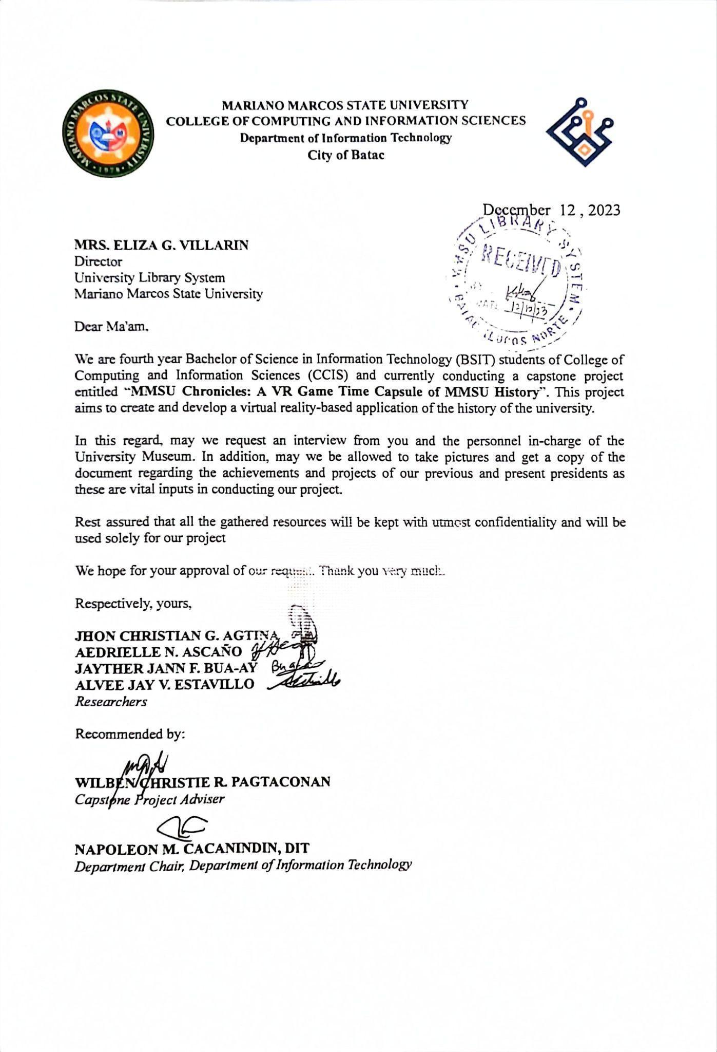

**Appendix B**

*University Research Ethics Review Board Clearance*

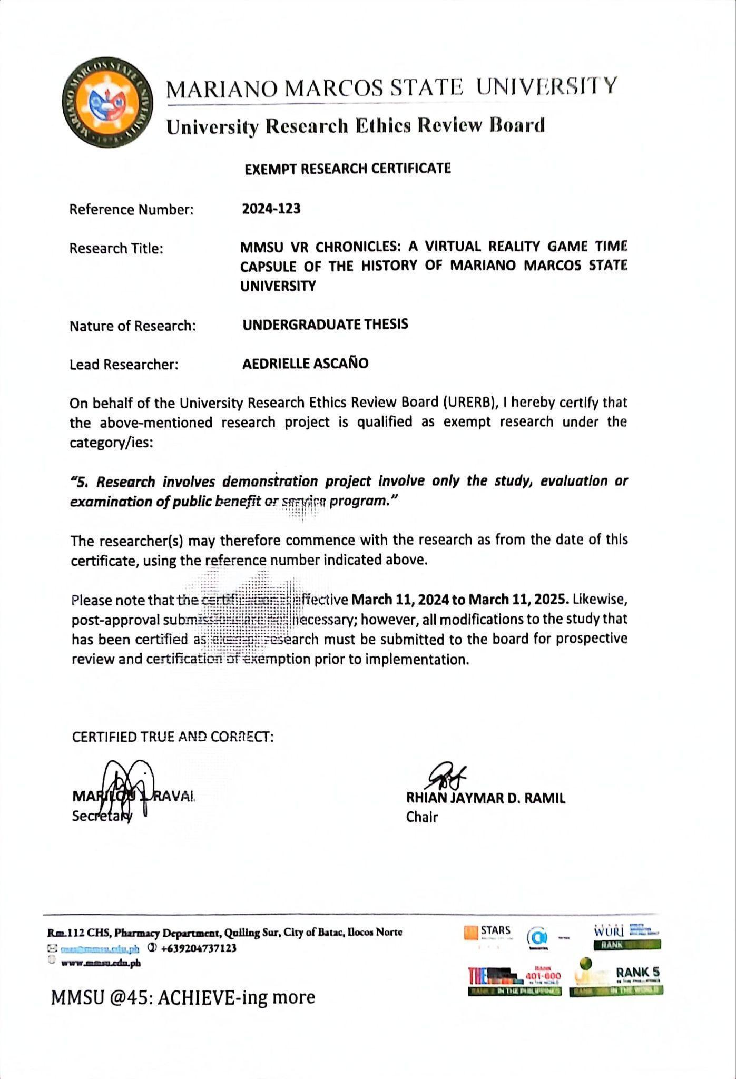

**Appendix C**

*Initial Survey Sample*

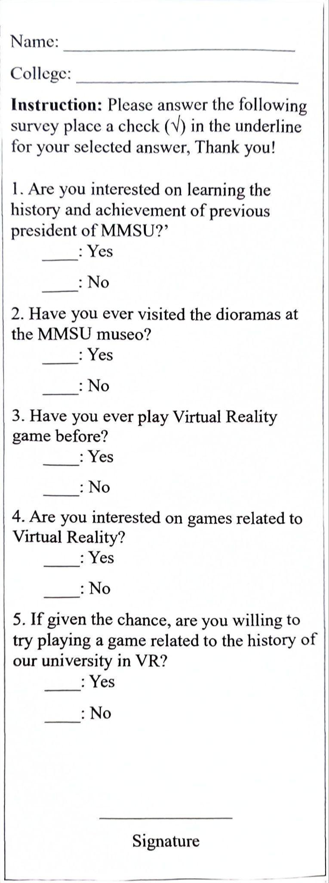

**Appendix D**

*User Acceptance Test Letter*

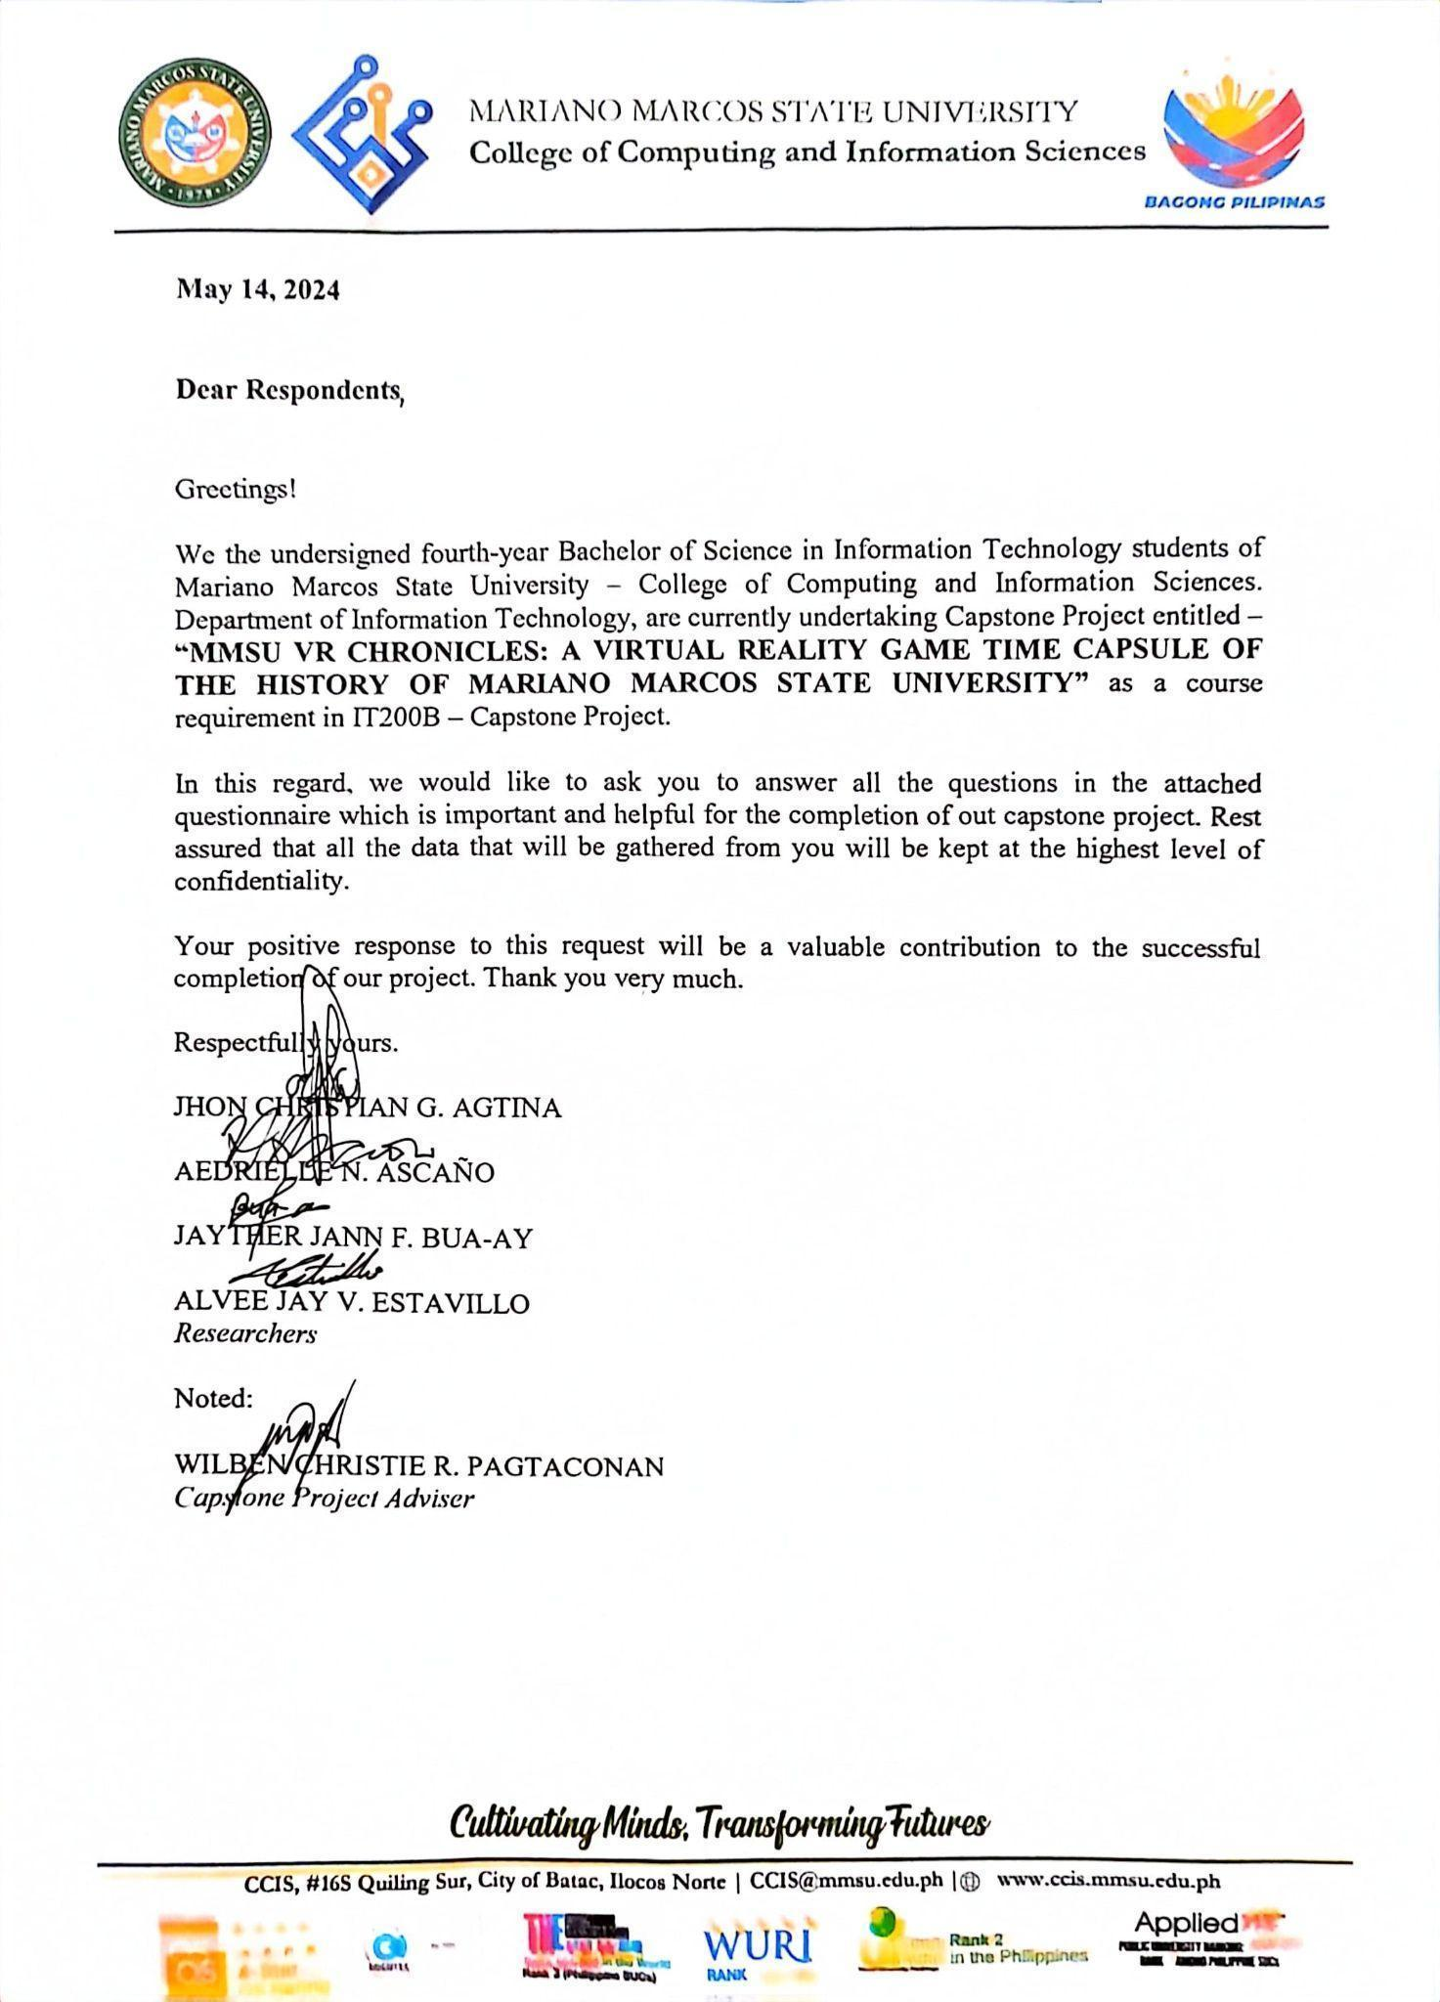

**Appendix E**

*User Acceptance Test Form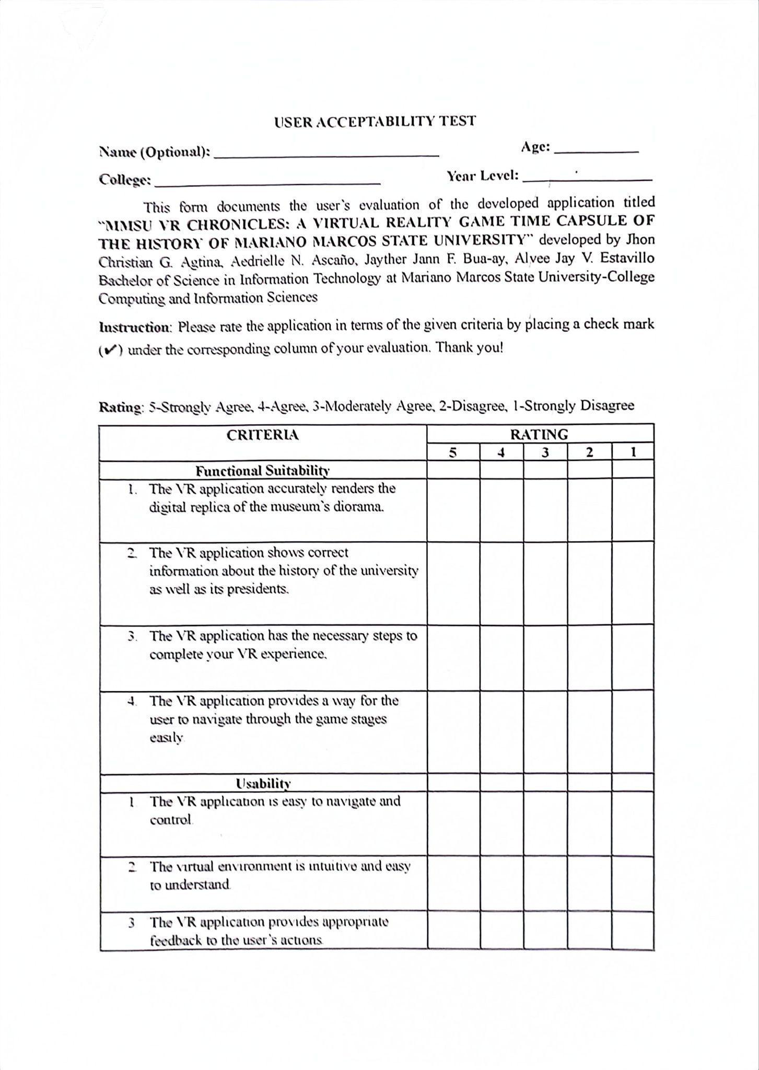*

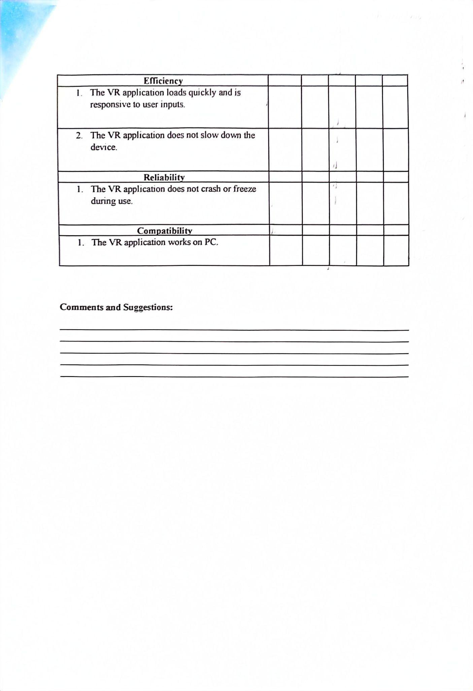

**Appendix F**

*Diorama Stage and Presidents’ Information*

**Stage 1**

* President E. Marcos is the commencement speaker during the last graduation exercises of MMMCST.
* MMMCST – Mariano Marcos Memorial College of Science and Technology.
* Marcos announced PD 1279 which created the Mariano Marcos State University (MMSU).

**Stage 2**

* Dr. Consuelo S. Blanco the first MMSU president.
* She supervises and points at ongoing infrastructure construction and MMSU-Batac Campus, particularly the administration building.
* During her term the infrastructure of MMSU started to rise with the help of the university architect, Arch. Bienvenido B. Magno.
* Her term duration is from June 1978 – May 1985
* Her educational attainment is a Doctor of Education
* She Graduated at University of California, Los Angeles, California U.S.A
* Achievements
* The physical plant and academic
* Three additional academic units were created, College of Arts and Sciences (CAS), College of Engineering (COE) and College of Economics (now it is called College of Business, Economics and Accountancy).
* MMSU became an active member in international organizations such as the International Association of Universities, International Association of Higher Learning, and Association of Technological Education in ASEAN.
* It also became a seat of an American Studies Resource Center in Northern Luzon, one of the four chosen in the country by the United States Information Service, Asia Foundation and American Studies Association of the Philippines.

**Stage 3**

* Dr. Santiago R. Obien is the second president of MMSU.
* His term Duration is from June 1985 – May 1987
* His educational attainment is Doctor of Philosophy Major in Soil Science and Herbicide and Weed Control.
* He graduated at University of Hawaii, Hawaii, U.S.A
* His achievement are:
* Formalized the research unit, strengthen research manpower by strengthening linkages with international and national research institutions, hiring capable/competent researchers and capability building of existing manpower resources through short-term training courses and seminar workshops.,
* Researchers from north to south came to observe the R&D activities of the university.
* New programs were prepared such as the university manpower development program (UMDP) and research proposal ‘Strengthening Applied Research and Training for Dryland Agriculture’ (SARTDA), which was granted funding by the Food and Agriculture Organization of the United Nations (FAO-UN).
* Dr. Felipe B. Cachola is the third president of MMSU
* His term duration is from June 1987 – May 1993
* His educational attainment is Doctor of Philosophy Major in Agriculture Education
* He graduated at University of the Philippines at Los Banos, Los Banos, Laguna, Philippines
* His achievements are:
* The University Manpower Development Program was at its peak.
* Several faculty members attended graduate studies, short-term trainings, study tours and conferences in accredited higher education institutions (HEI’s) not only in the Philippines but also in the United States, Europe, Australia and Asia.
* The curricular offerings of three academic units, GS, CAF, and CE were accredited by the Accrediting Agency fir Chartered Colleges and Universities of the Philippines (AACCUP), which raised the integrity and quality of teacher education and agricultural degree programs both in the undergraduate and graduate levels.
* Students excelled not only in academics but also in co-curricular activities.
* ROTC unit was adjudged as outstanding in Region 1 and CAF Student Council became one of the Three Outstanding Youth Organizations of the Philippines (TOYOPHIL).
* Implementation of two internationally funded research projects Strengthening Applied Research and Training for Dryland Agriculture or SARTDA and ‘Strengthening the Garlic Industry, Philippines’.
* The Food and Agriculture Organization of the United Nations and the International Development Research Center funded the projects.
* These projects were instrumental in the implementation of the university’s manpower development program in HEI's abroad.

**Stage 4**

* Dr. Elias L. Calacal is the fourth president of Mariano Marcos State University.
* He defined his administration’s development agenda along with the visions of the Pres. Fidel V. Ramos for the country toward the year 2000.
* During his time of administration, the academe continued as the showcase of developments in instruction, research, extension and production as well cultural, social and scientific dynamism competitive not only regionally but also worldwide.
* His term duration is from June 1993 – May 1999
* His educational attainment is Doctor of Philosophy Major in Material Science Engineering.
* Graduated at University of Washington D.C., U.S.A.
* His achievements are:
* In his administration university facilities were improve with the repair of many buildings and expansion of the university theater, which was later named as “Teatro Ilocandia”.
* Excellence in academic and co-curricular activities handed over by the past Presidents was sustained and under his administration, the university was designated as Center of Excellence in Teacher Education and Center of Development in Ceramics Engineering.
* Programs in the various colleges were accredited by the AACCUP.
* The CBEA and CHS became the third among the top performing schools in accountancy and nursing, respectively, in the Licensure Examinations.
* Became extensive as the university reached municipalities in fulfillment of its social reform agenda. In research, ILARRDEC, with MMSU as the lead agency, won the prestigious Ugnay Award 1996.
* MMSU also won a lot of research awards at the regional and national level.

**Stage 5**

* Dr. Saturnino M. Ocampo Jr. is the fifth president of Mariano Marcos State University.
* A man of visions, a seasoned scientist, educator, organizer, and outstanding public servant.
* Leads the University at the turn of the millennium toward genuinely dynamic and relevant developments in all aspects for which the University exists guided by the values of integrity, industry, and independence.
* His term duration is from June 1999 – December 2004
* Educational Attainment: Doctor of Philosophy Major in Research Design and Methodology.
* He graduated from Ohio State University.
* His achievements are the following:
* His administration implemented well-balanced four-fold functions: research, extension and production.
* Internal efficiency was heightened by closing/freezing programs that did not prove viable.
* The Integrated University High Schools was phased out in compliance with BOR Resolution implementing the transfer of non-laboratory schools to the Department of Education and attaching the laboratory schools to mother colleges offering the educational course.
* External linkages were highly strengthened, R & D was refocused for relevance and impact, innovative technology promotion strategies were initiated, and computer literacy was highly promoted among university constituents.
* Additionally, efforts were intensified in agribusiness projects that are generating substantial income, while at the same time scrapping those at the borderline.
* Facilities were augmented through the establishment of a physical therapy building, tissue culture and biotechnology laboratory and glasshouse, 4 staff housing units and a two-storey students’ dormitory under the congressional funds of Hon. Imee R. Marcos, representative of the second district of Ilocos Norte.
* The university is also awarded an institutional development grant for the purchase of biotechnology and IT equipment and for the implementation of DA-BAR agriculture and Fisherman Research and Development Information System.
* The university was re-designated as Center of Excellence in Agricultural Engineering, Special Center of Development in Agriculture and CHED Zonal Research Center for Region 1, Region 2, and CAR.
* MMSU students and graduates showed exemplary performance in various competitions and licensure examinations, giving honor to the University as among the top performing in nursing, pharmacy, physical therapy, accountancy and electrical engineering. ILARRDEC with MMSU as the lead agency again won the prestigious Ugnay Award in 2004.